**Project Phase - V -> Testing in a DevOps Lifecycle**

1. **CI/CD Deployment for Springboot Application**

This Project is Developed by Anushka Sharma. This project is hosted on the git repository : <https://github.com/AnushkaSharma9/phase5-Project-CI-CD-Deployment-for-Springboot-Application.git>

* 1. **PROJECT DESCRIPTION**

This application is designed and developed to automate the integration and deployment of the web-application, which is in its final stage.

**1.1.2 TECH STACK**

* Core Java Concepts - Object Oriented Programming (OOPS) Concepts such as Classes and Objects.
* Eclipse
* Maven
* Spring Boot Framework
* AWS EC2 instance
* Jenkins
* Docker

1. **FLOW CHART OF THE APPLICATION**

The below given picture depicts the flow of the Deployment :

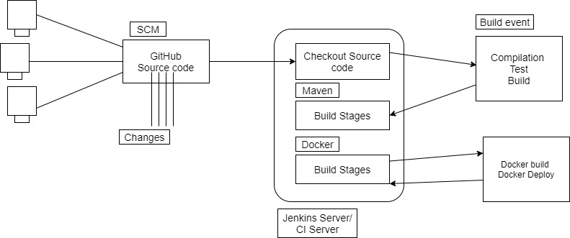

**FIG 1 - FLOW CHART OF THE DEPLOYMENT**

1. **PROJECT USER STORIES : (Agile and Scrum)**

* As a user I want an automated integration of a Spring boot Application.
* As a user I want an automated deployment of a Spring boot Application.
* As a developer I want to automate the integration of a Spring boot Application for the user.
* As a developer I want to automate the deployment of a Spring boot Application for the user.

1. **SPRINTS**

**Sprint 1**

* Understanding the problem statement of the project .
* Creating the flow chart of the project.
* Creating Maven Project.
* Creating Spring boot Application.
* Adding necessary dependencies.
* Testing at each step for different user inputs.
* Initializing the git repository.
* Pushing the code to the GitHub.
* Creating AWS EC2 instance.
* Downloading MobaXterm.
* Downloading Jenkins and Docker in MobaXterm.
* Deploying the application on Jenkins and docker server.
* Creating the Specification document for deploying the project.

1. **PROJECT GIT REPOSITORIES**
2. Link to the GitHub Repository :

<https://github.com/AnushkaSharma9/phase5-Project-CI-CD-Deployment-for-Springboot-Application.git>

1. Screen Shot of GitHub :

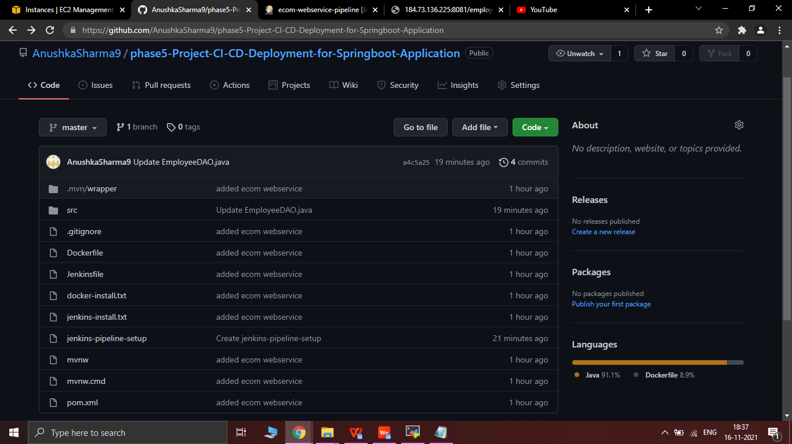

1. How to run Project :
   1. First create EC2 Instance on AWS as follows:

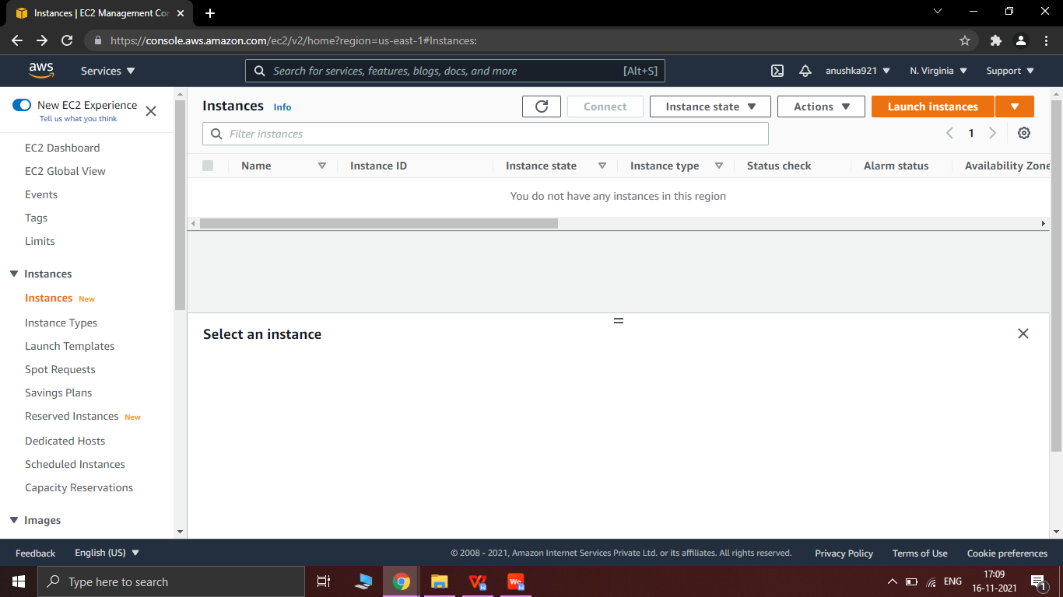

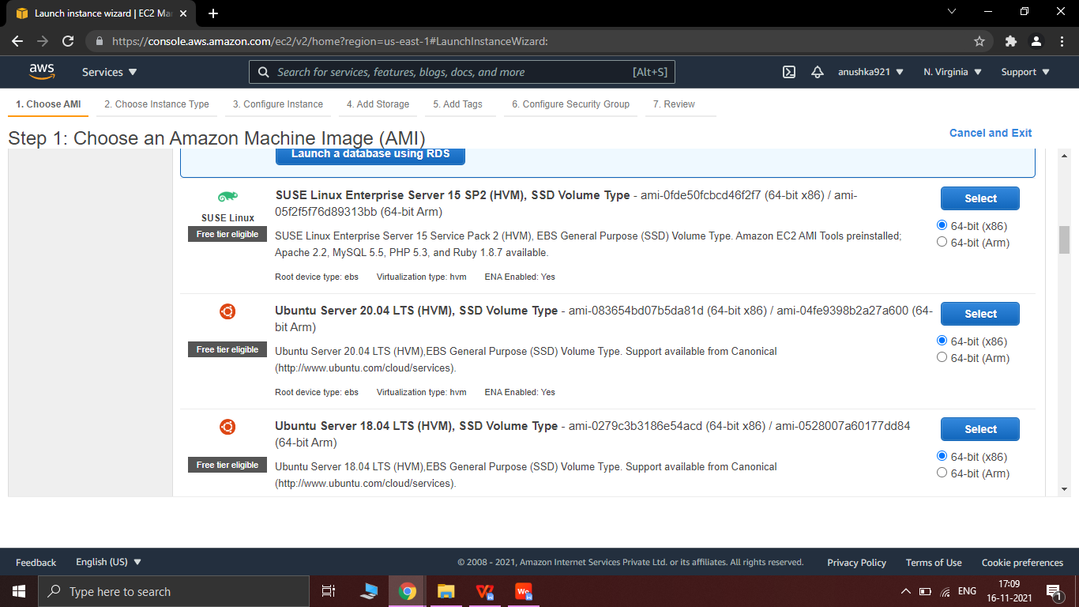

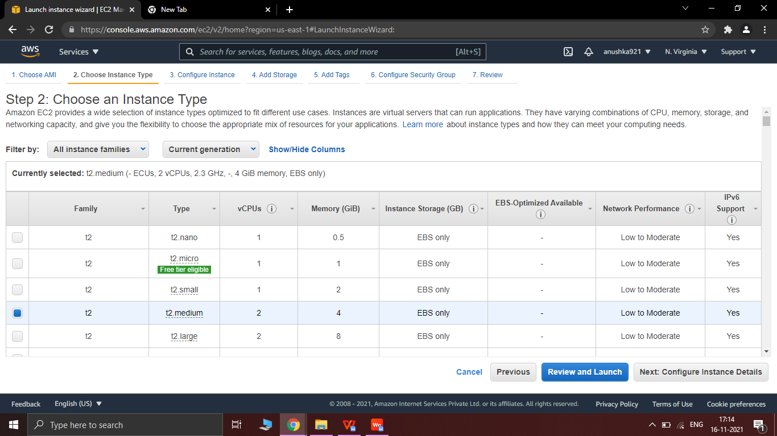

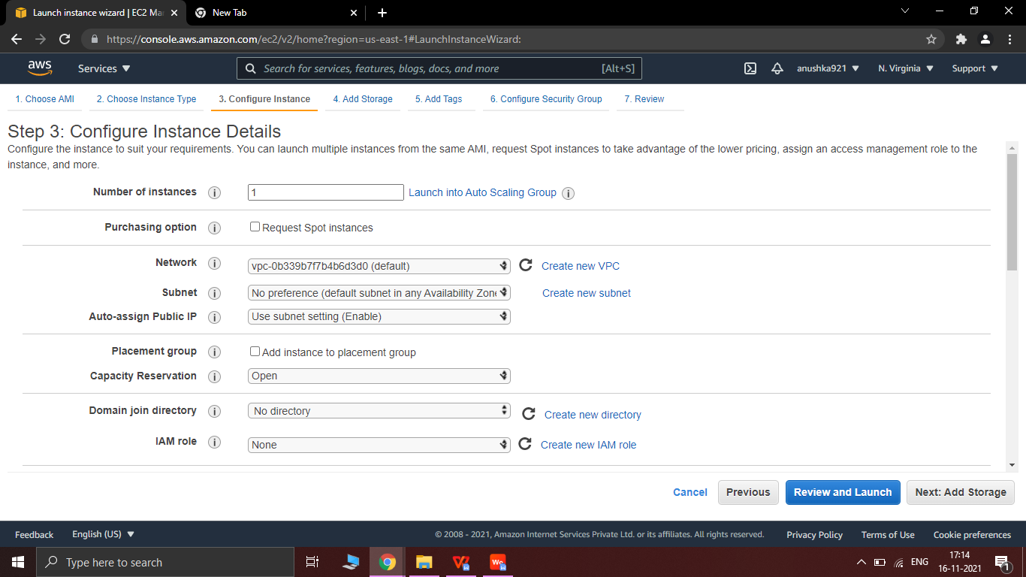

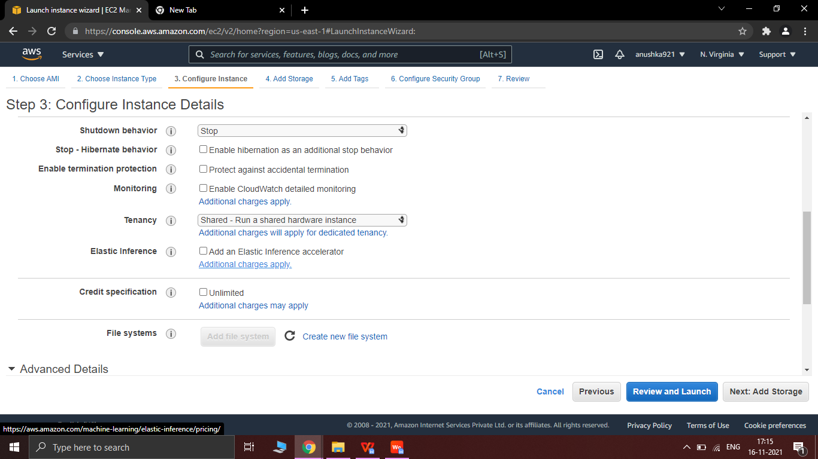

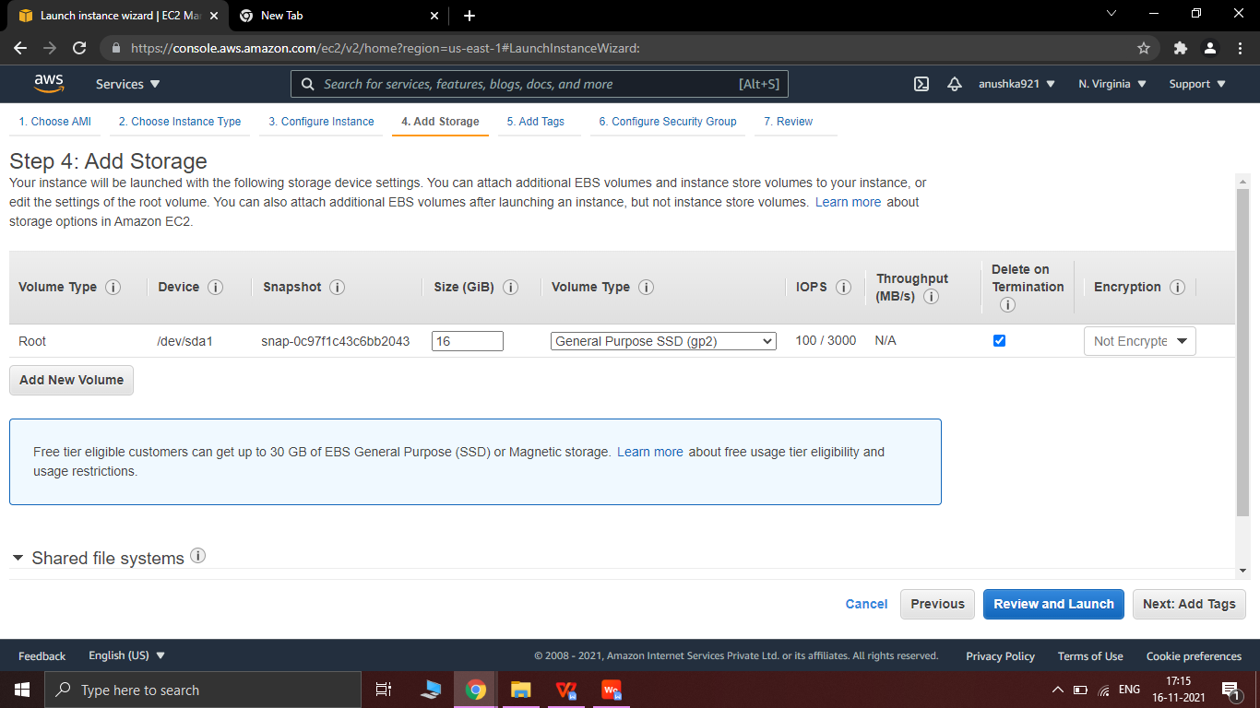

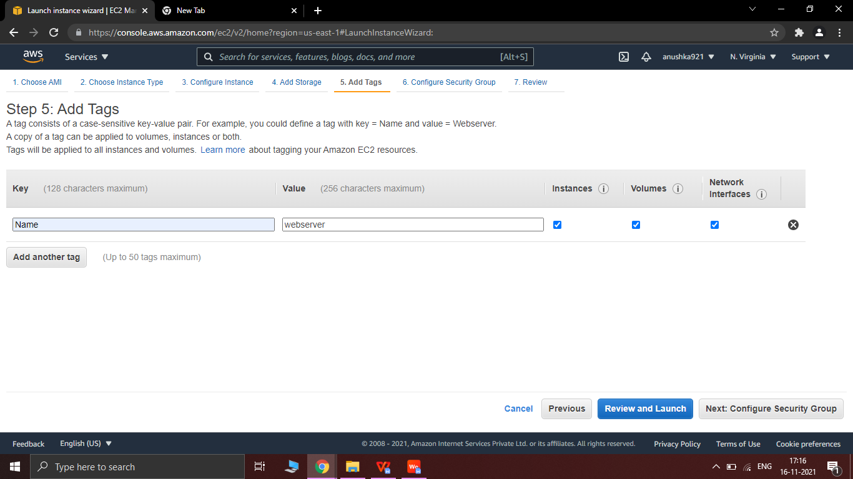

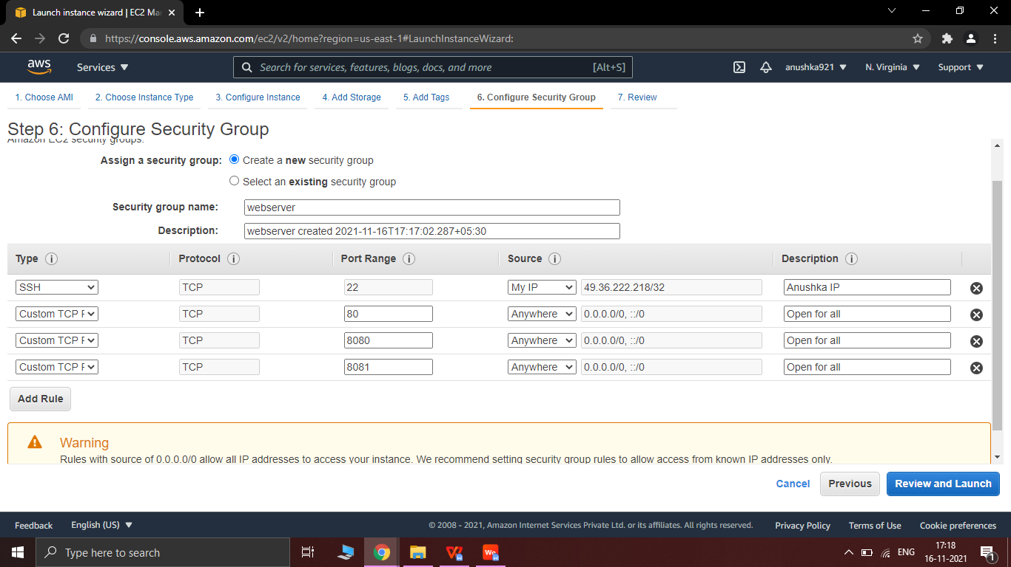

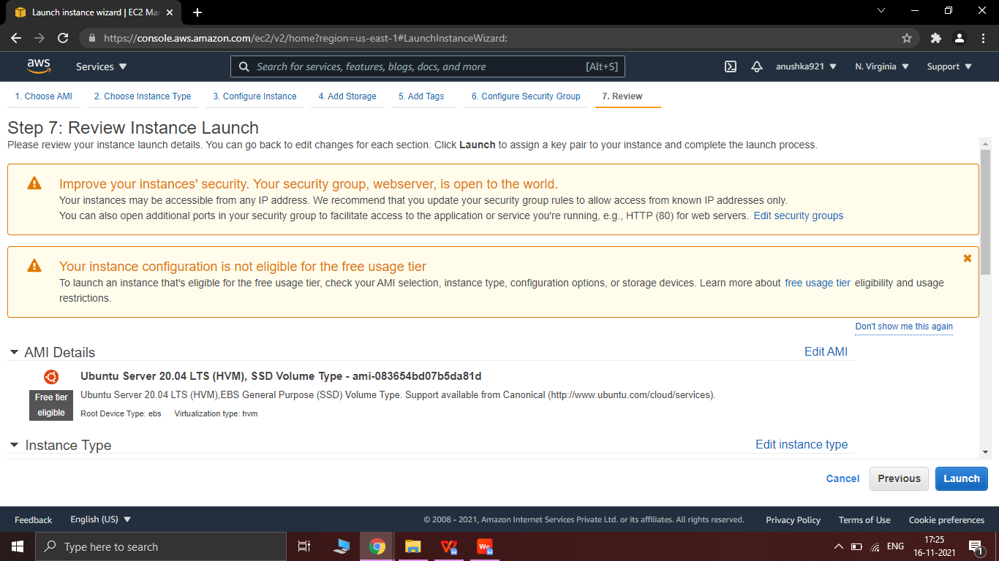

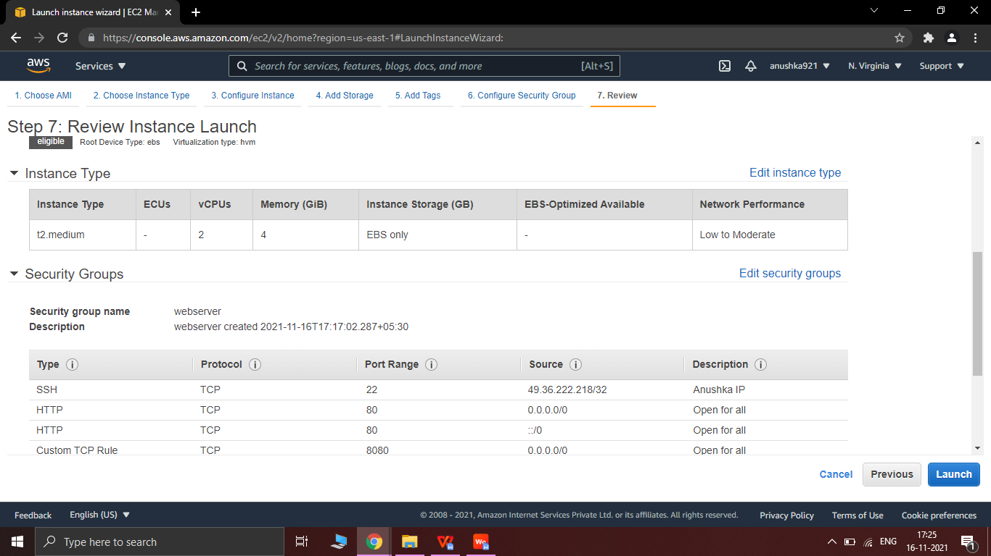

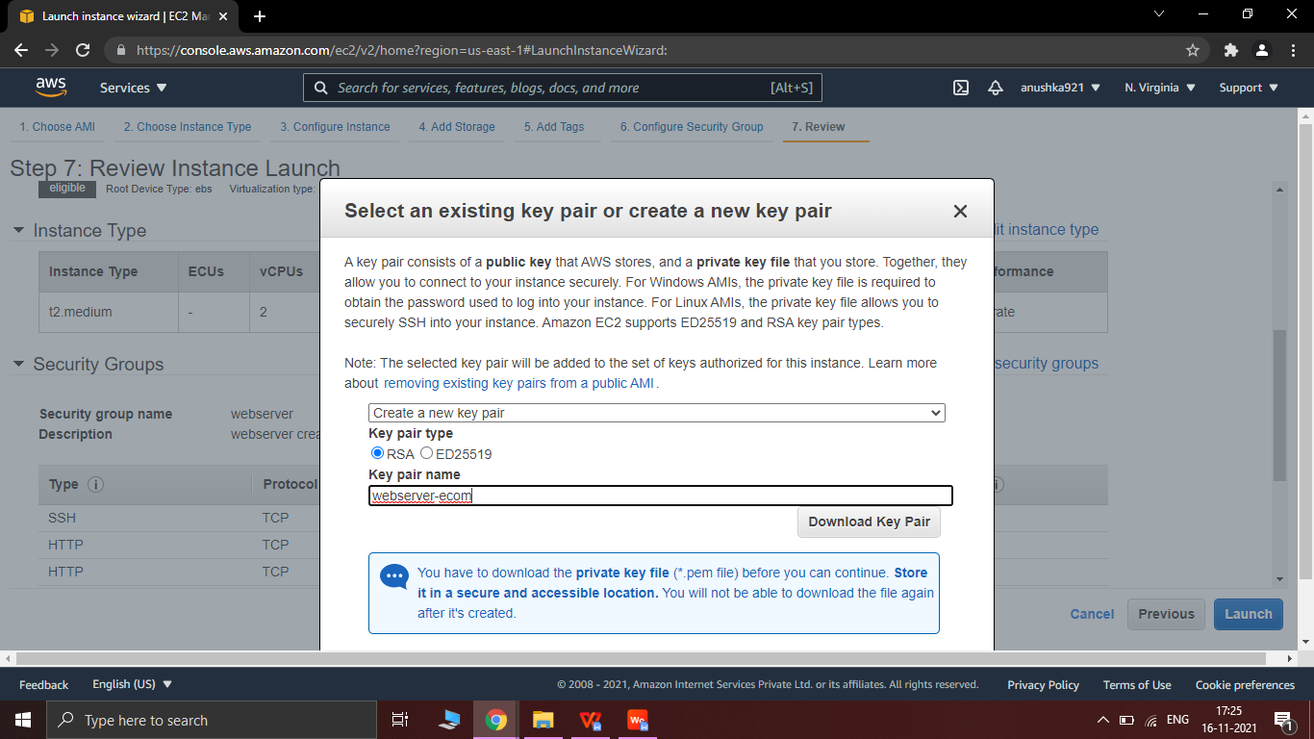

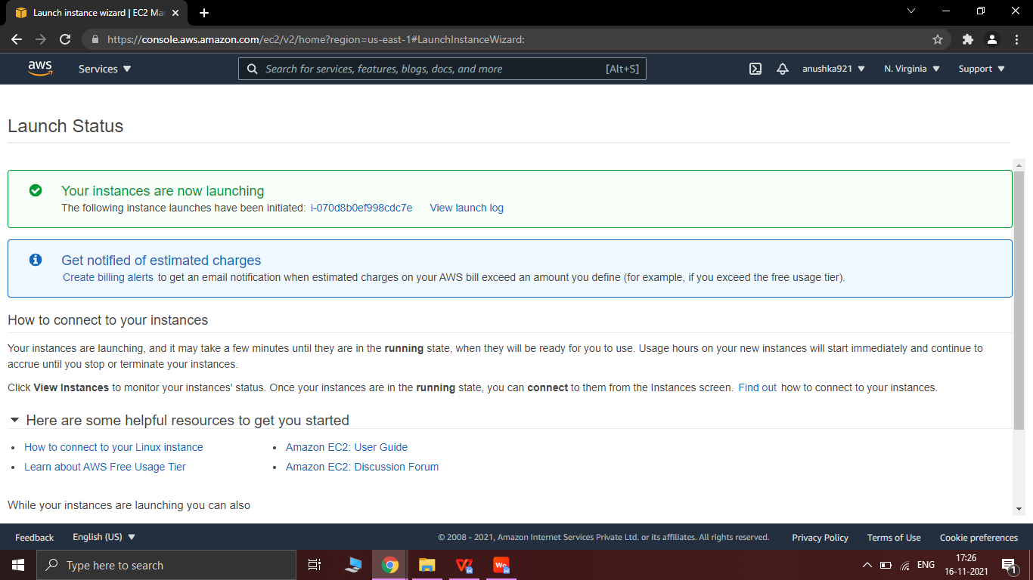

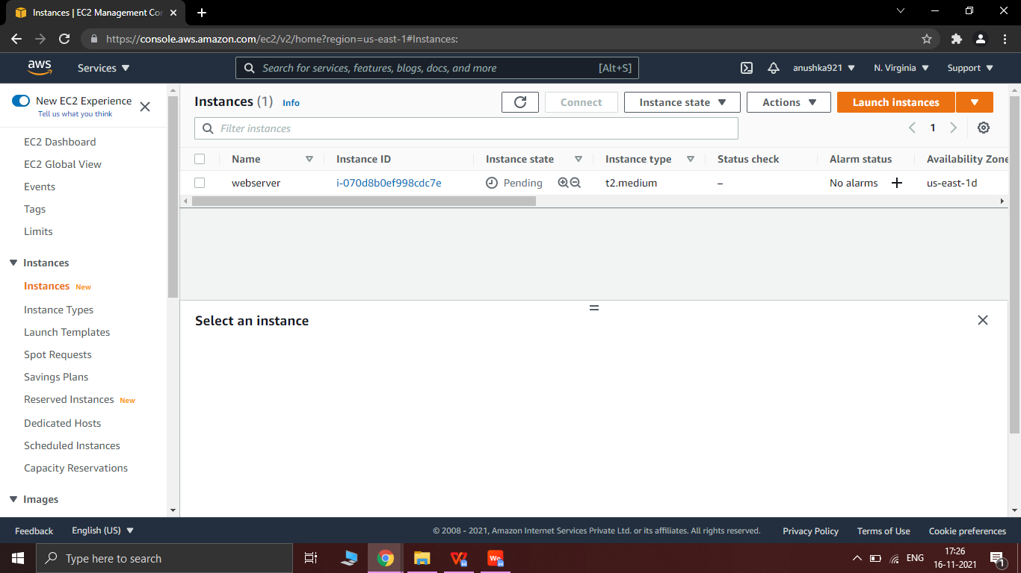

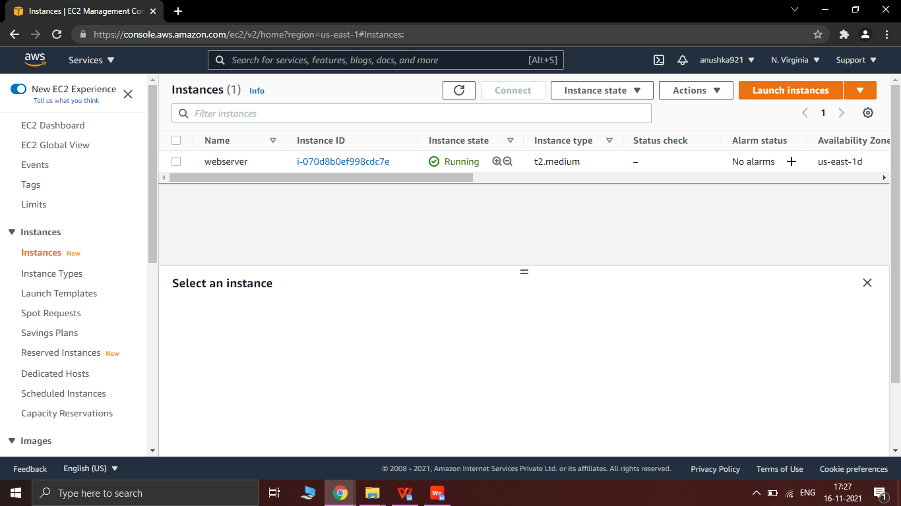

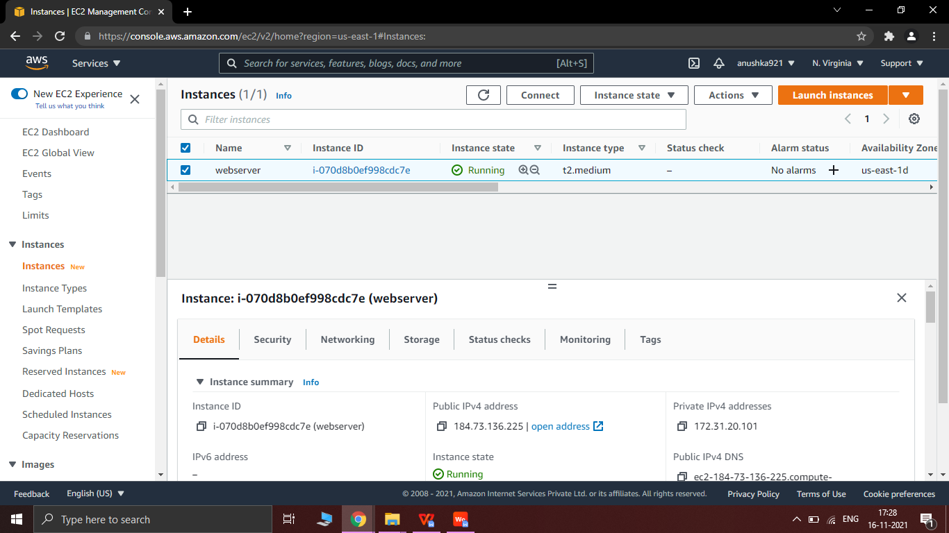

3.2 Put key In MobaXterm :->ssh -i "webserver-ecom.pem" ubuntu@ec2-184-73-136-225.compute-1.amazonaws.com

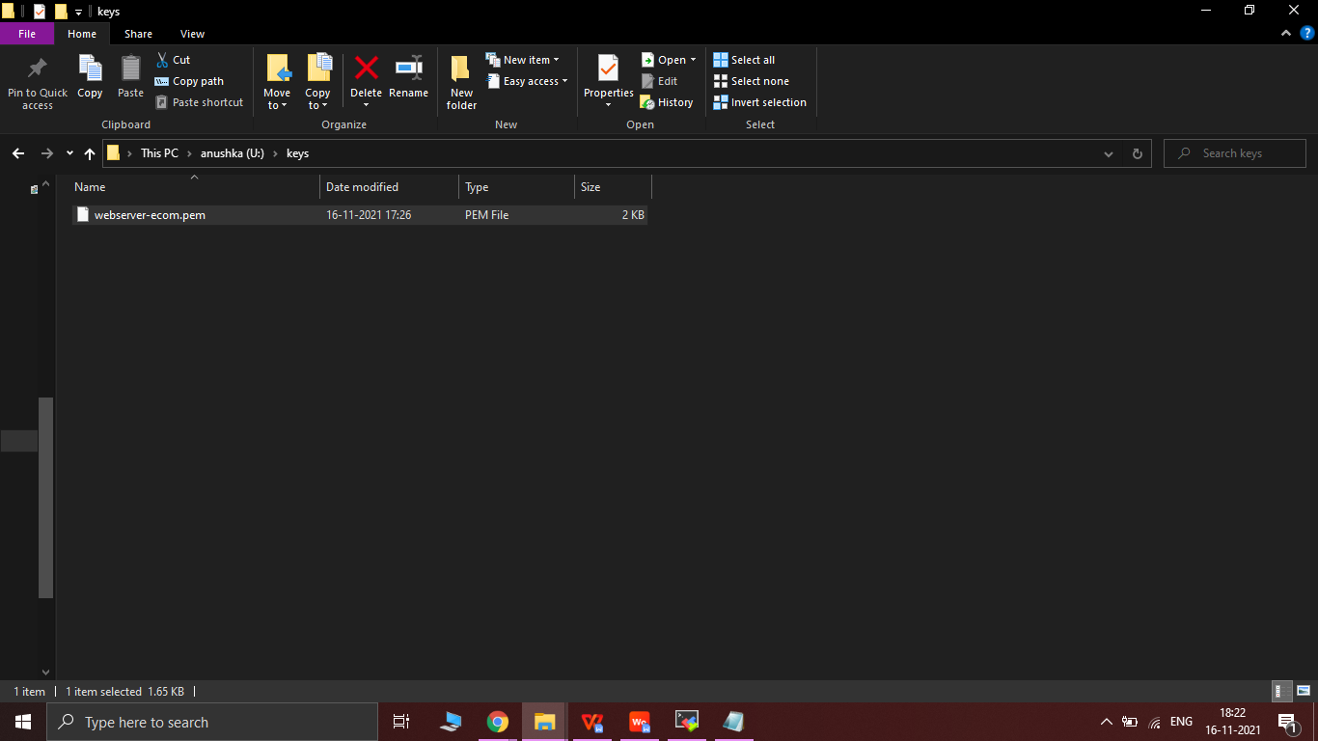

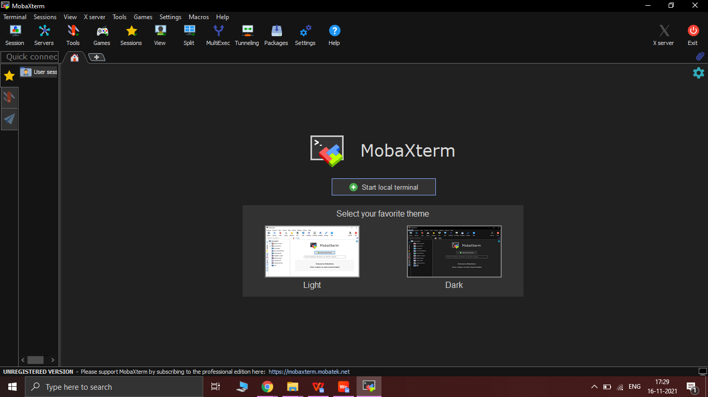

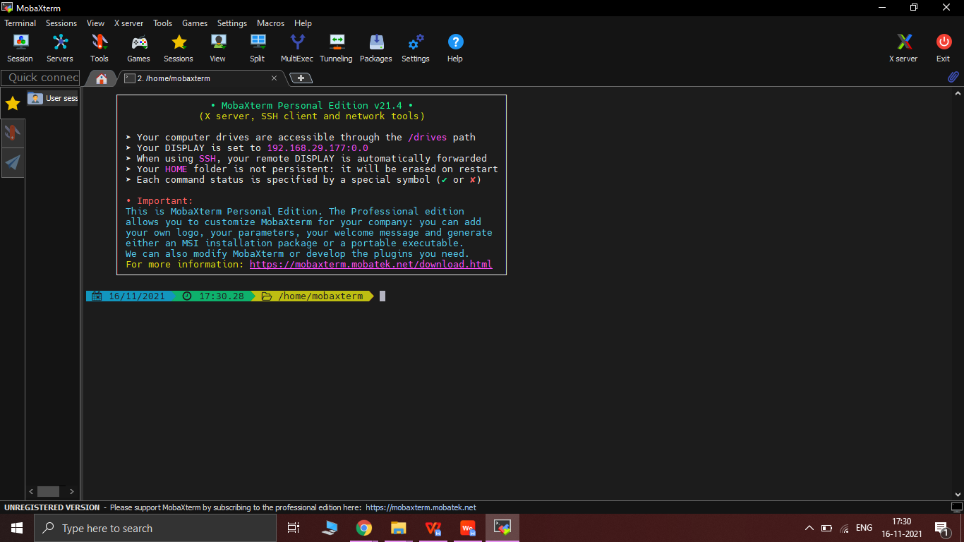

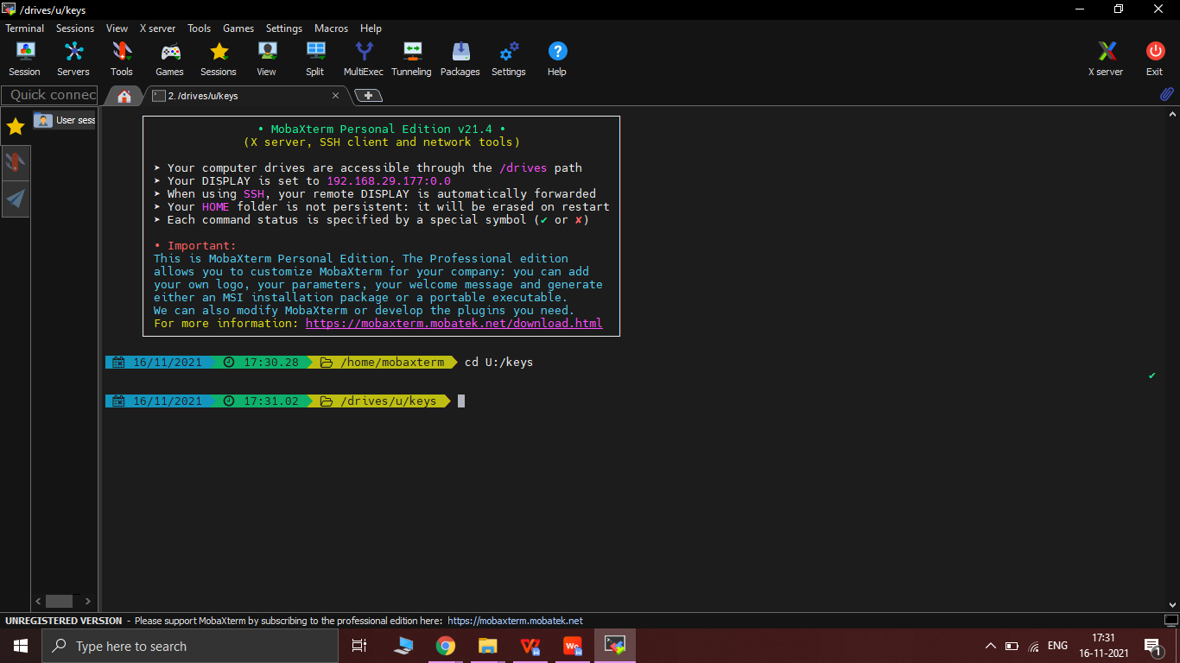

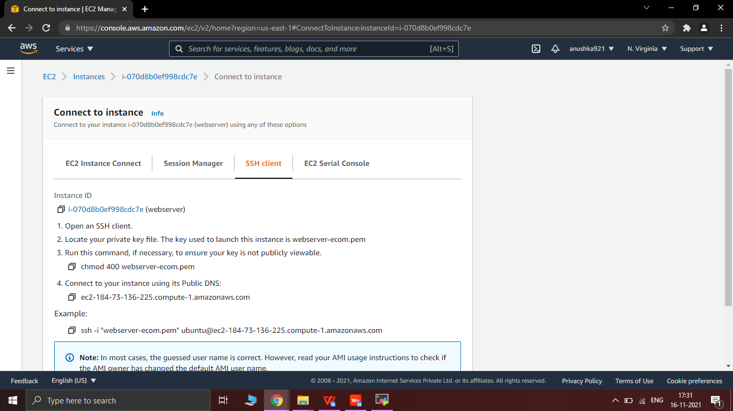

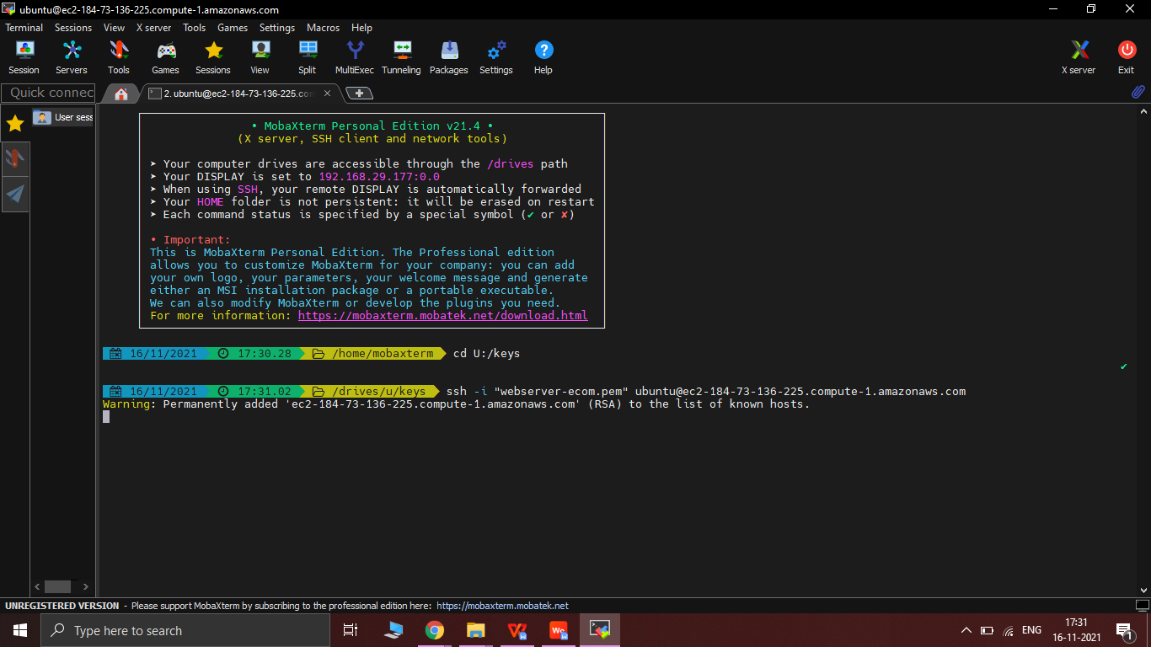

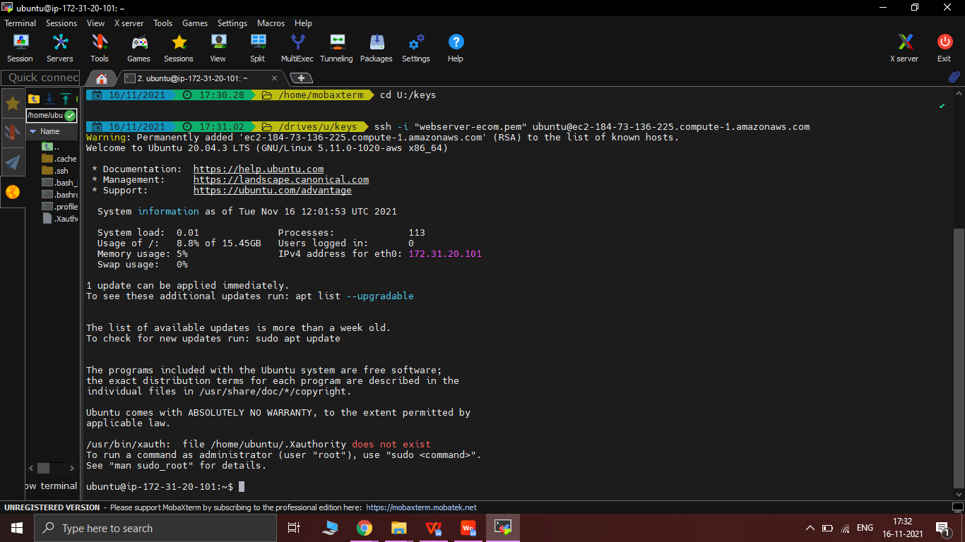

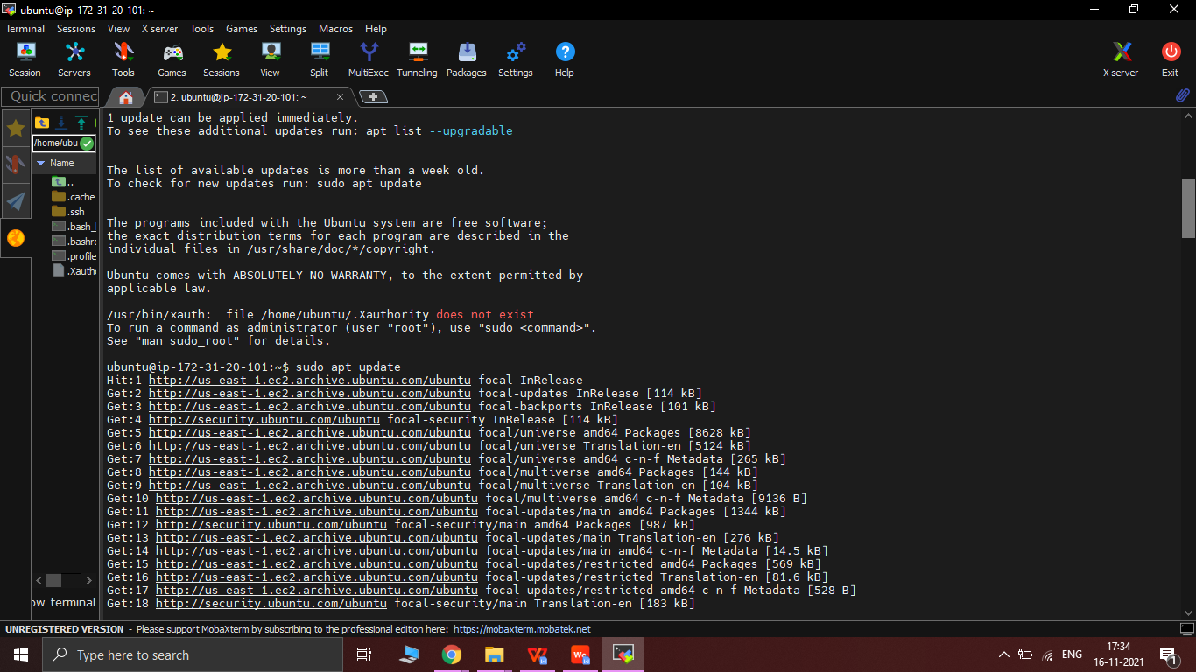

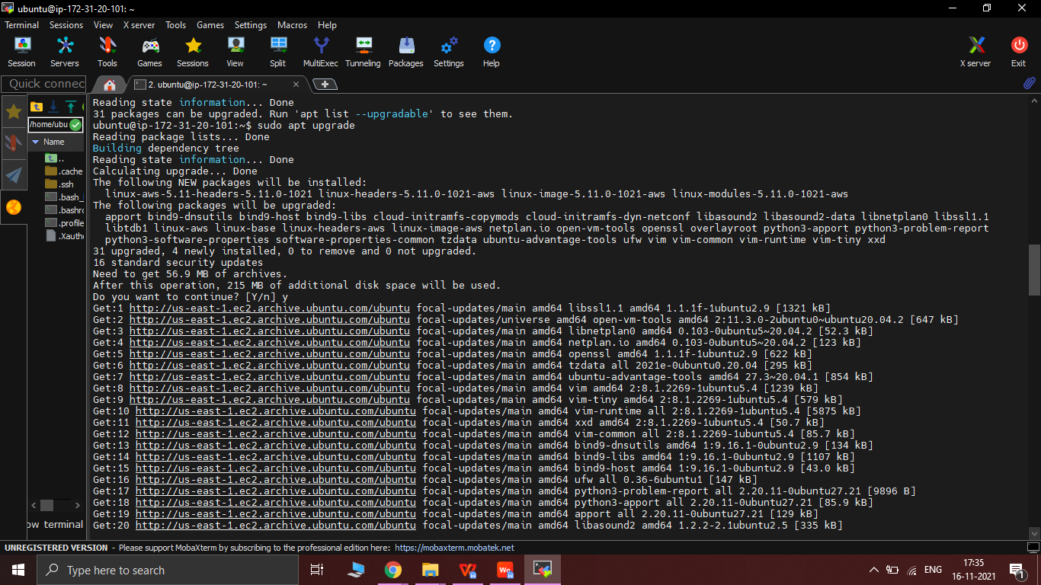

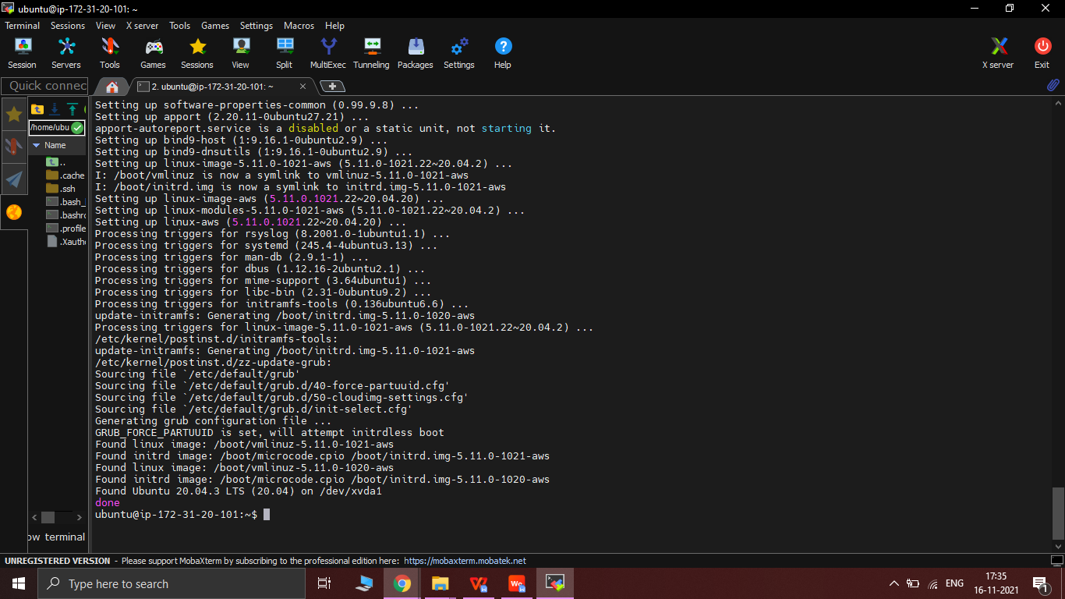

3.3 Install Jenkins server on MobaXterm : -

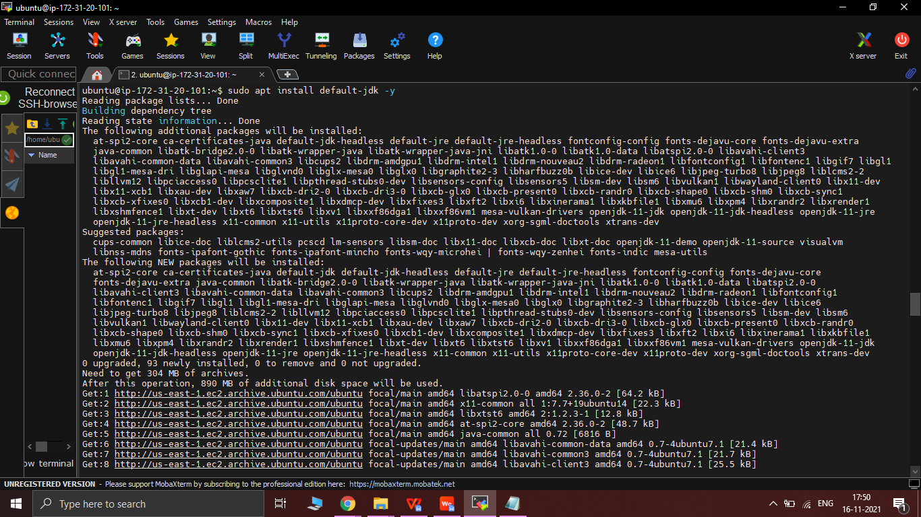

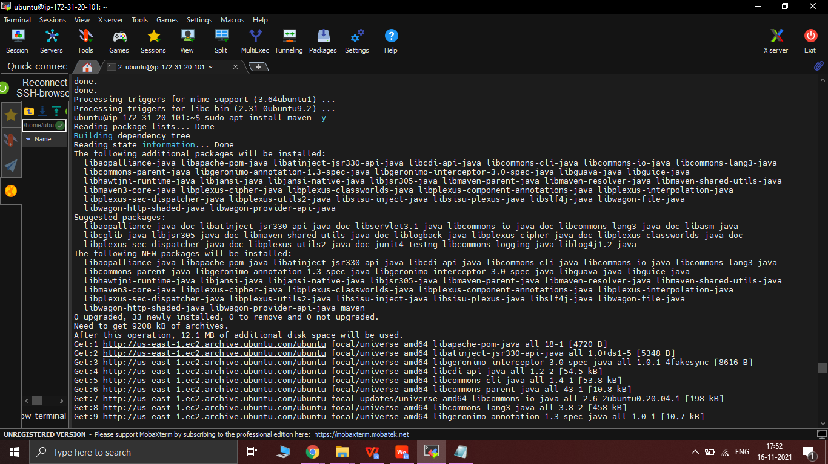

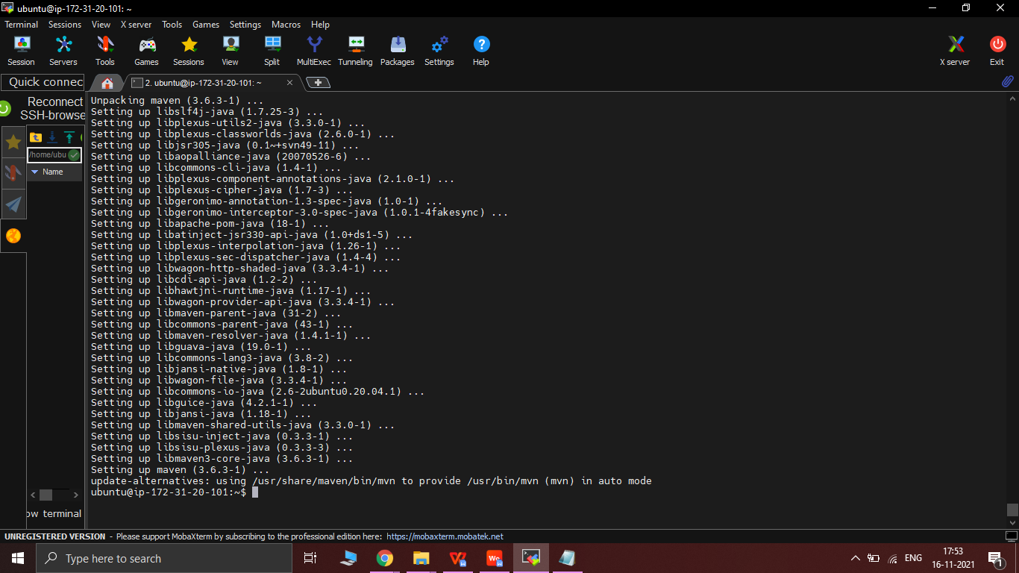

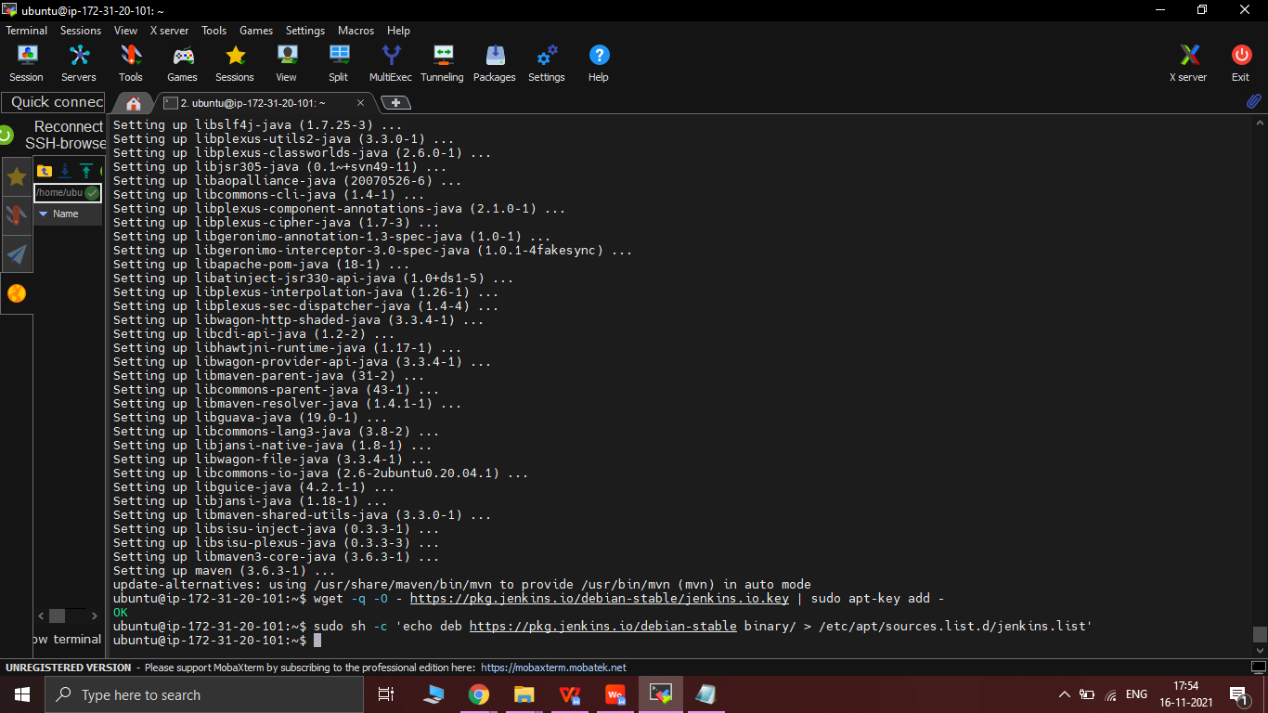

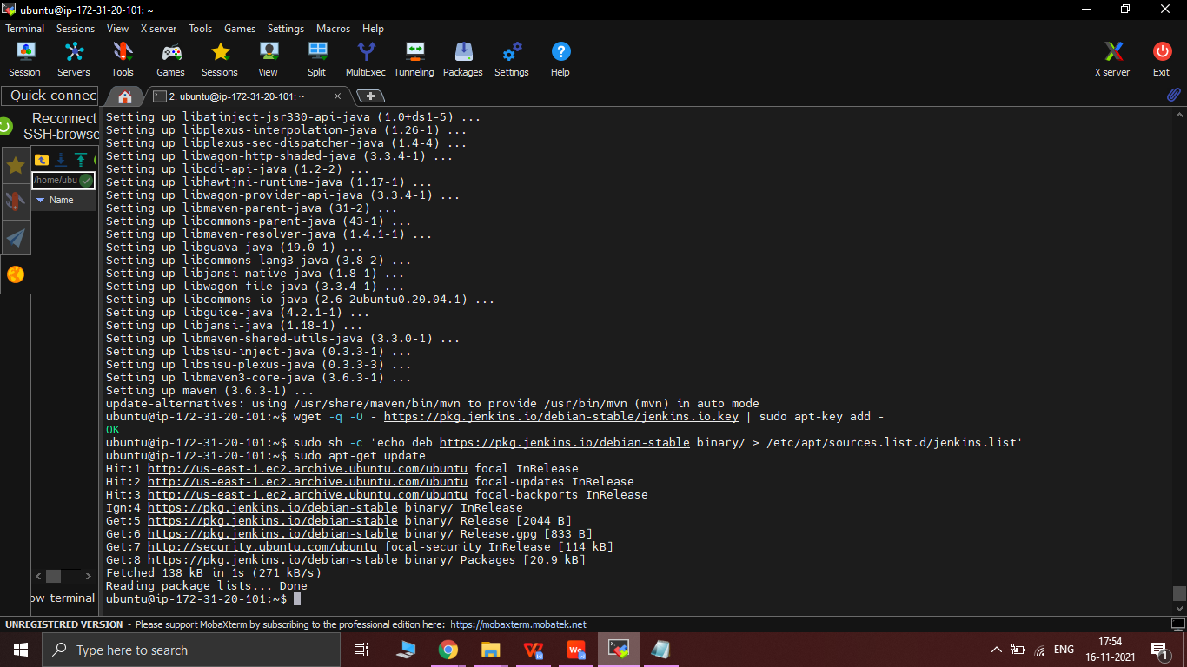

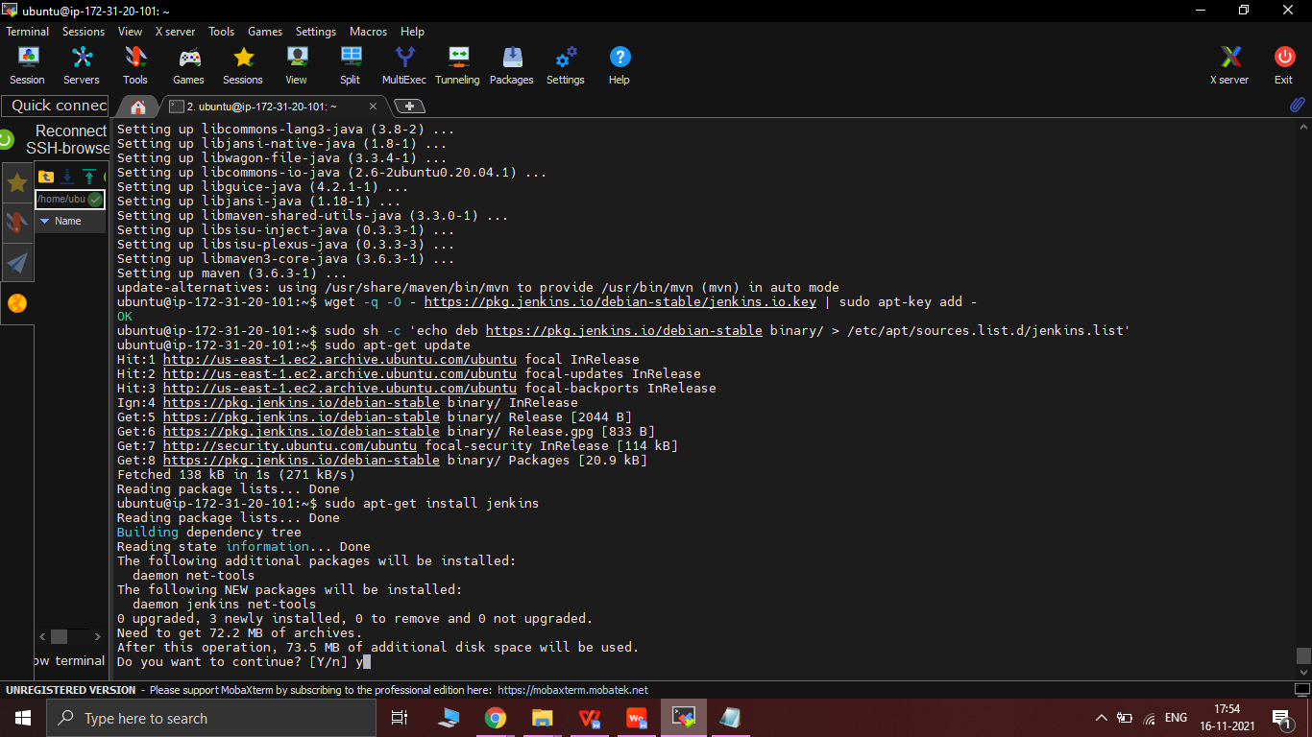

3.4 Install Docker server in MobaXterm :-

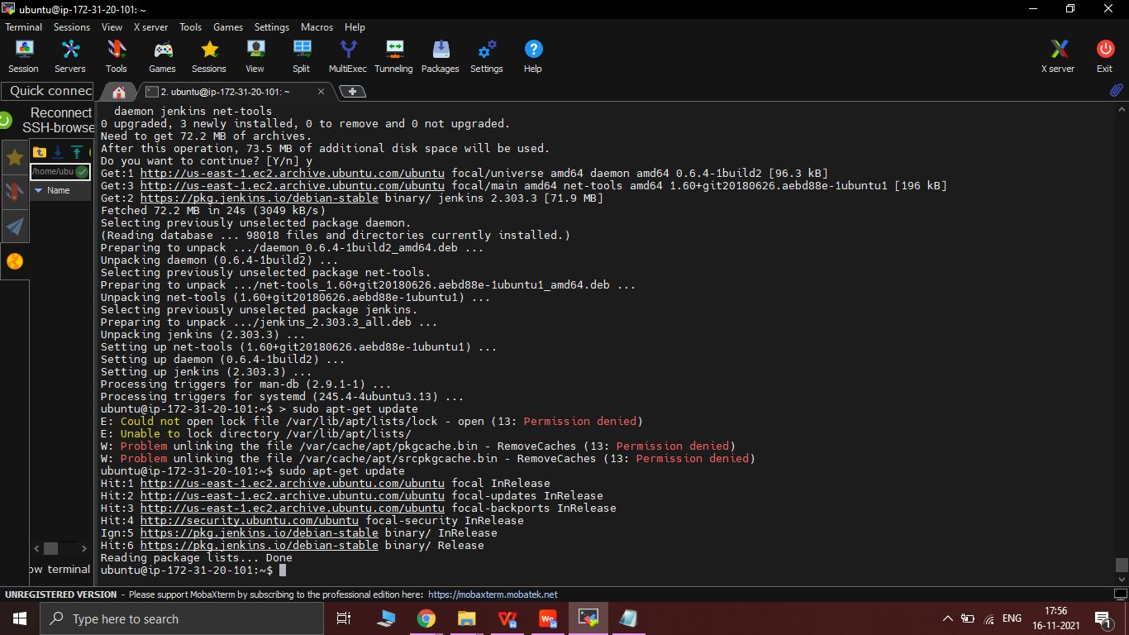

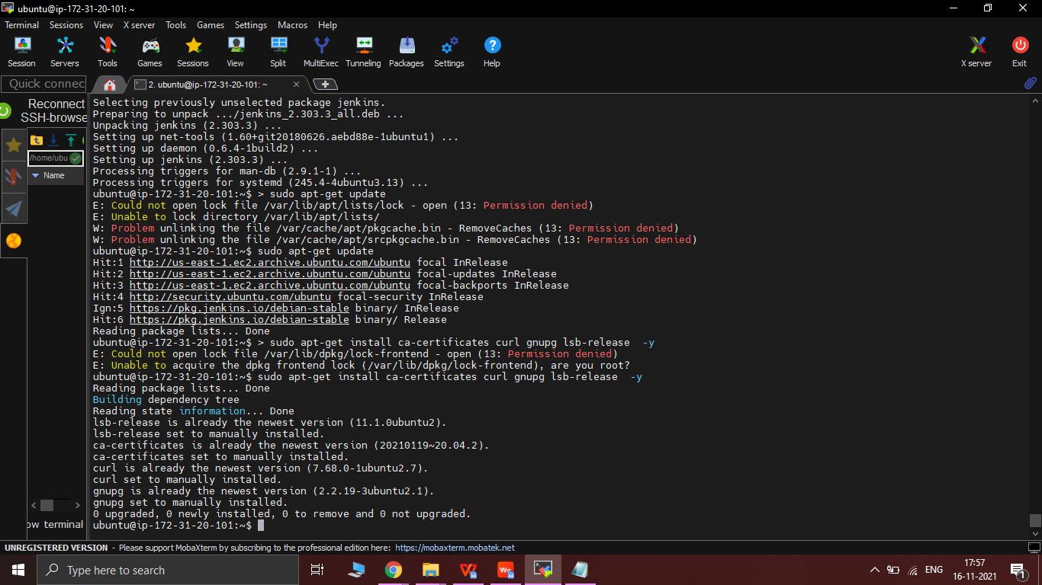

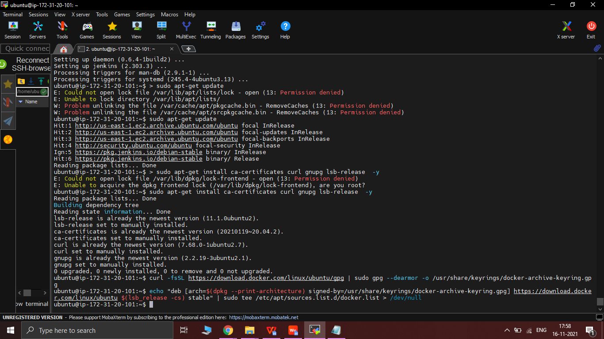

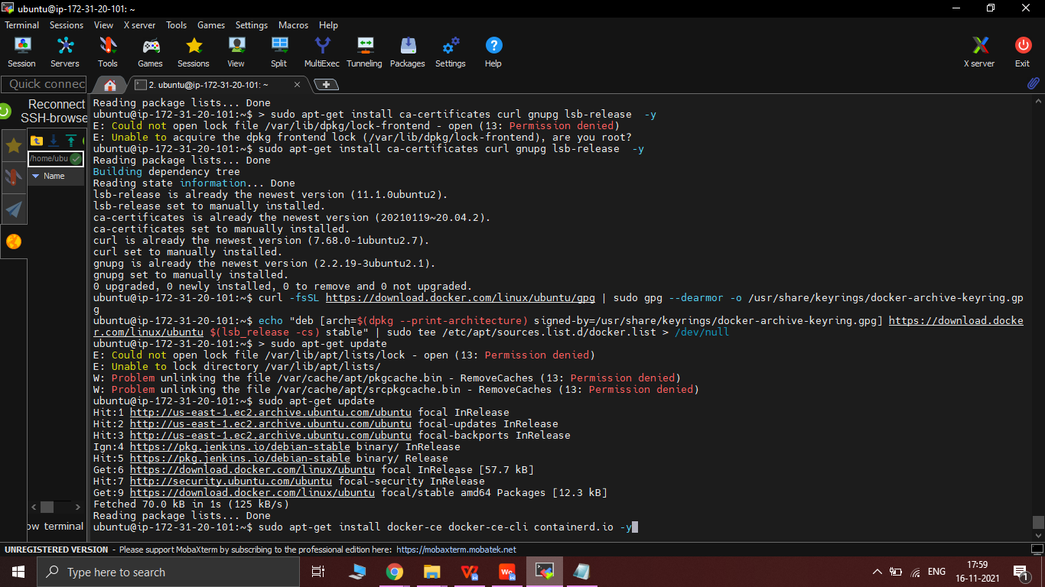

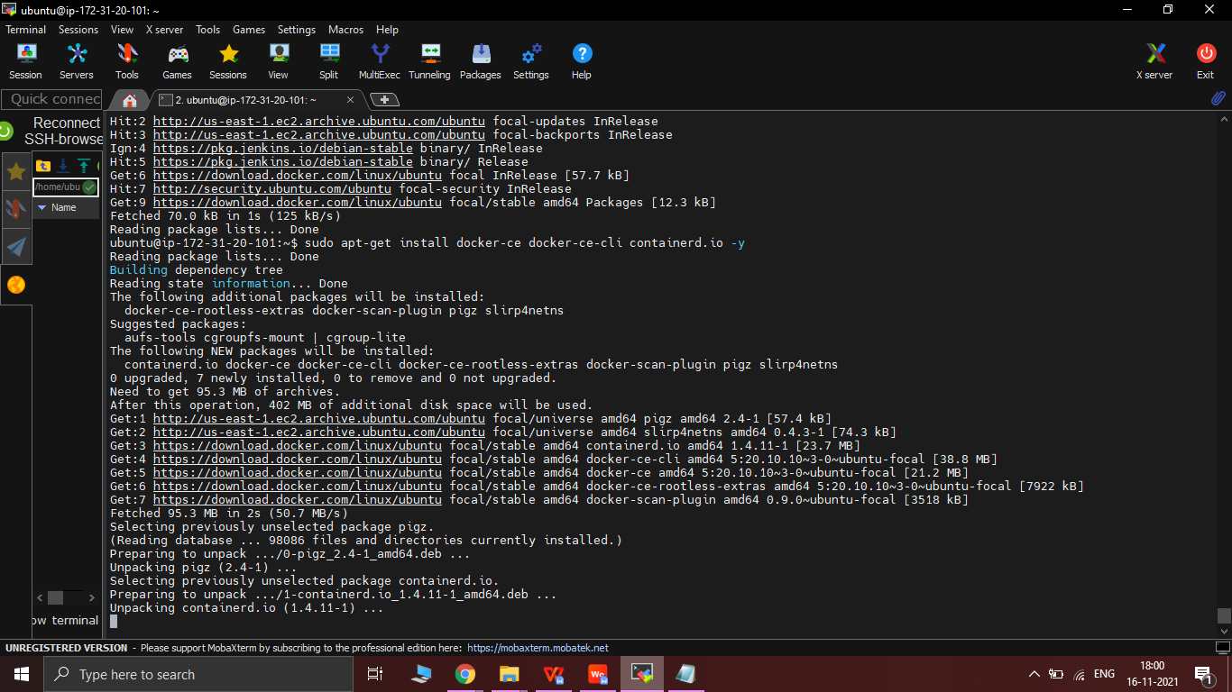

3.5 Run Jenkins on port /0.0.0.0:8080

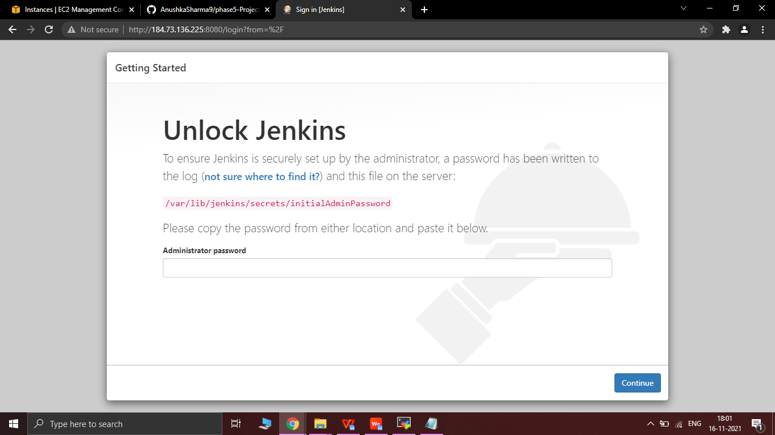

* Put the Administrator password as shown in the picture -

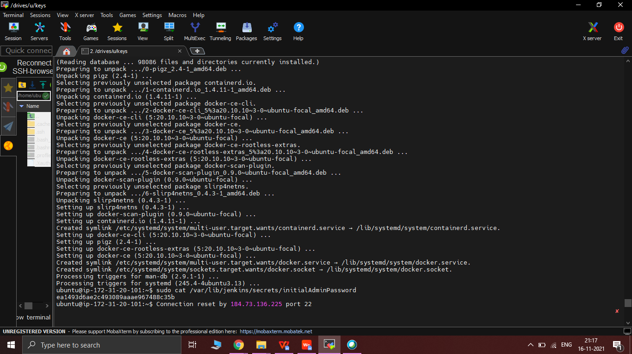

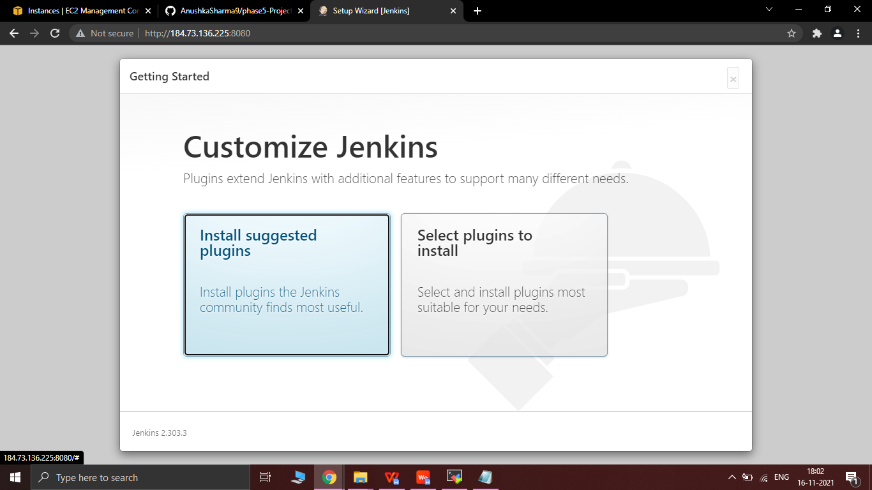

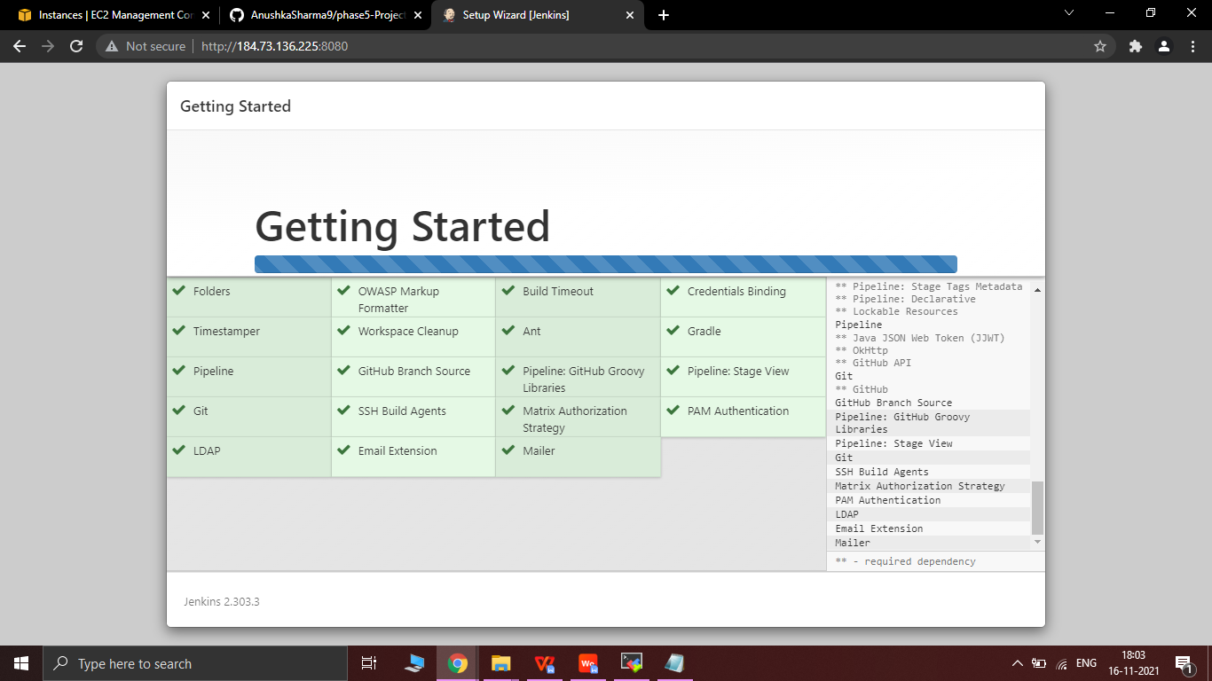

3.6 Put Username and Password in Jenkins as :

* Username - admin
* Password - admin

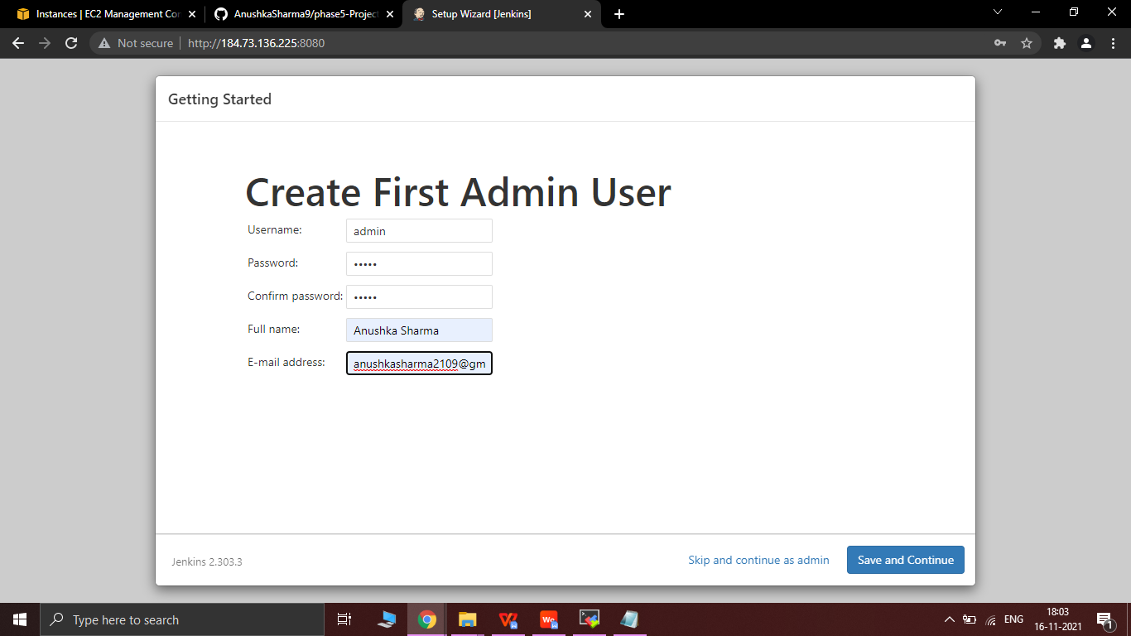

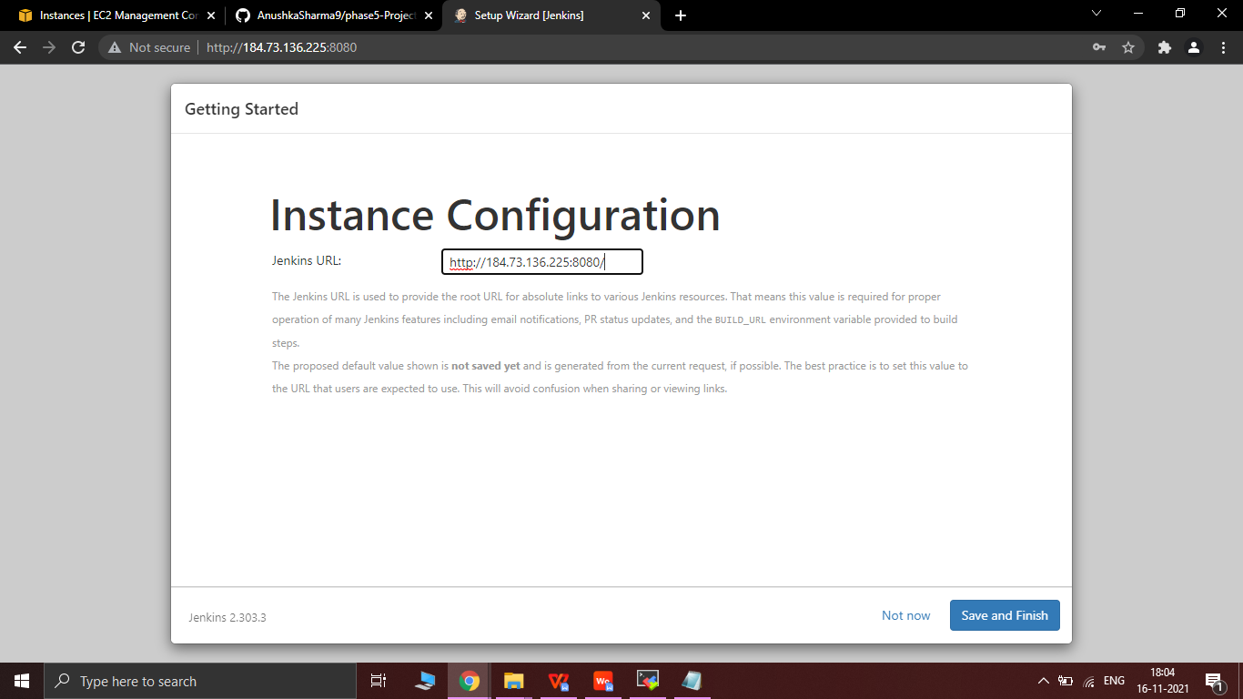

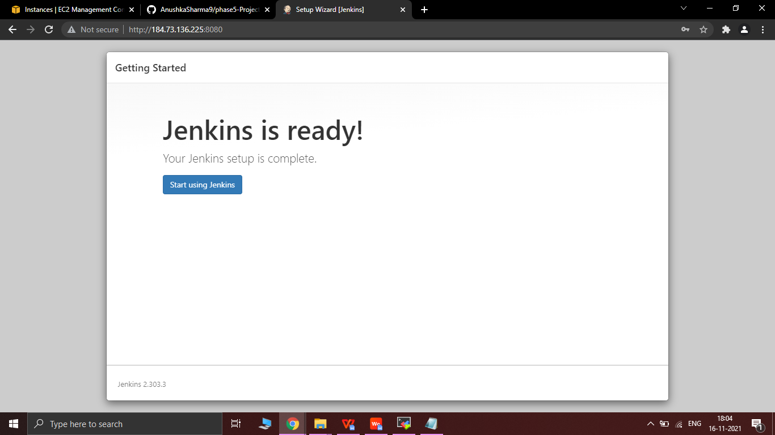

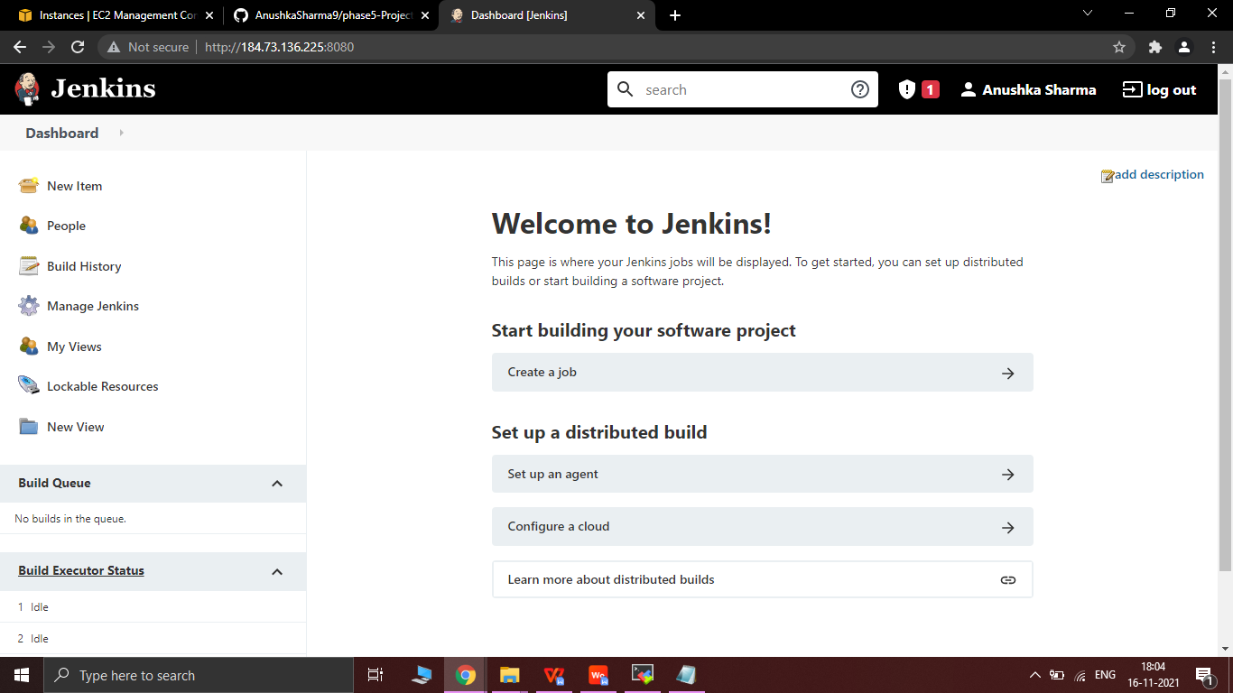

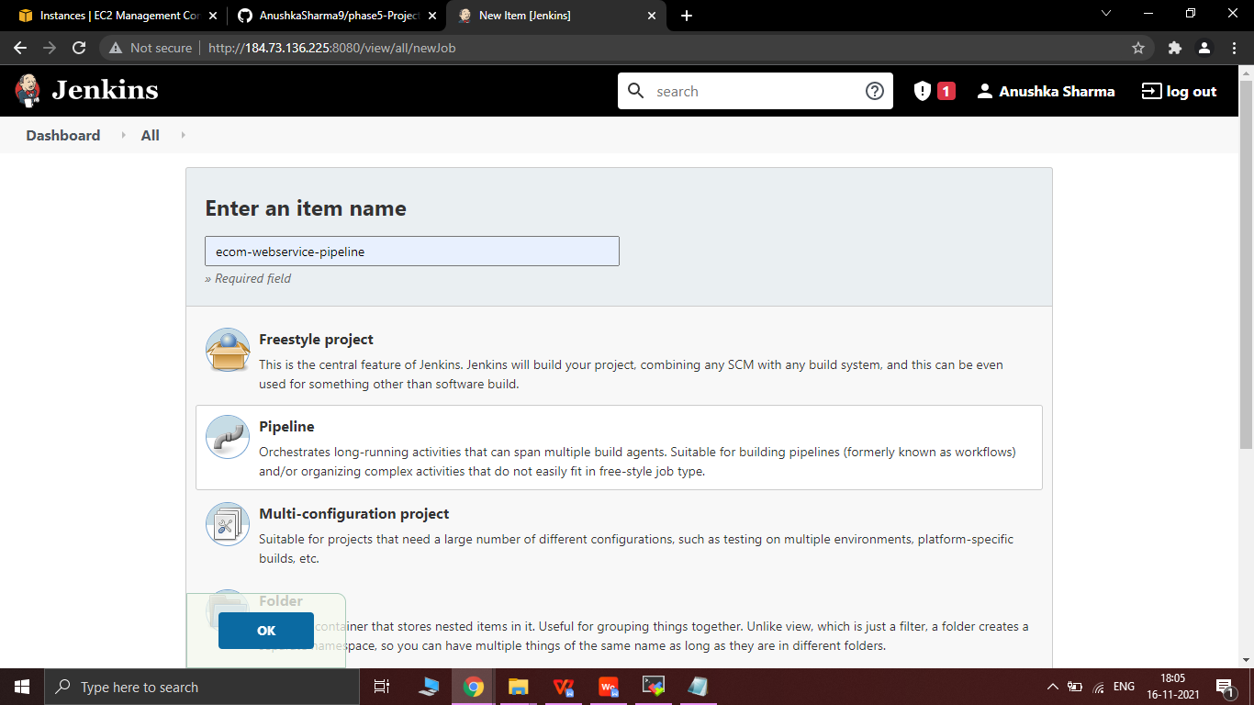

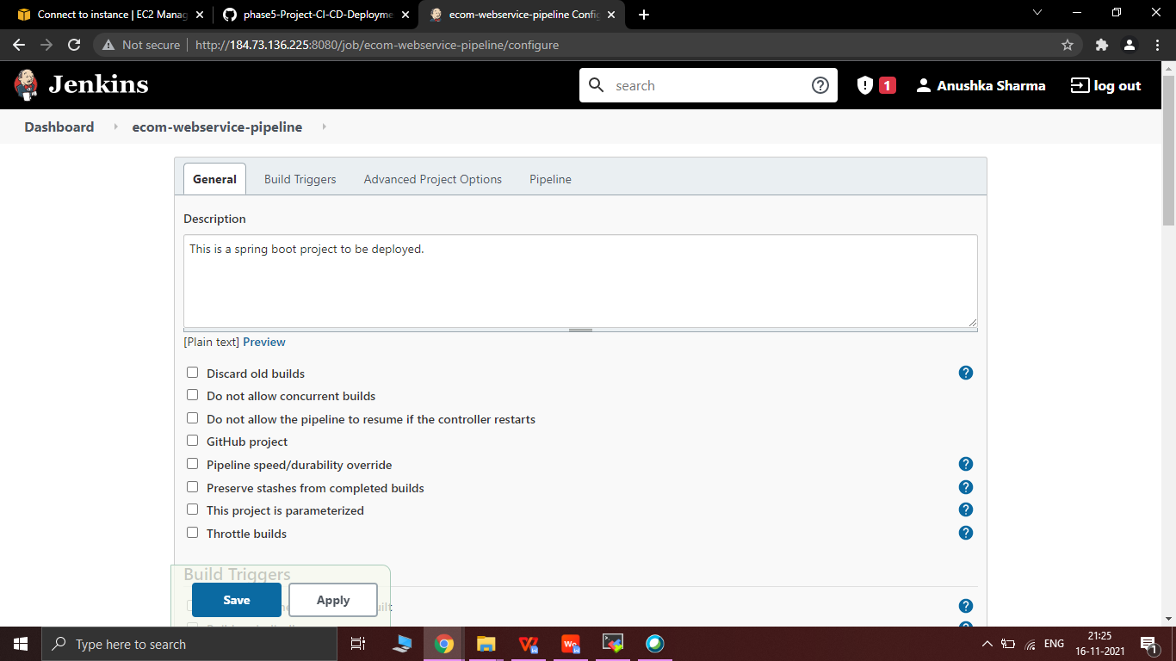

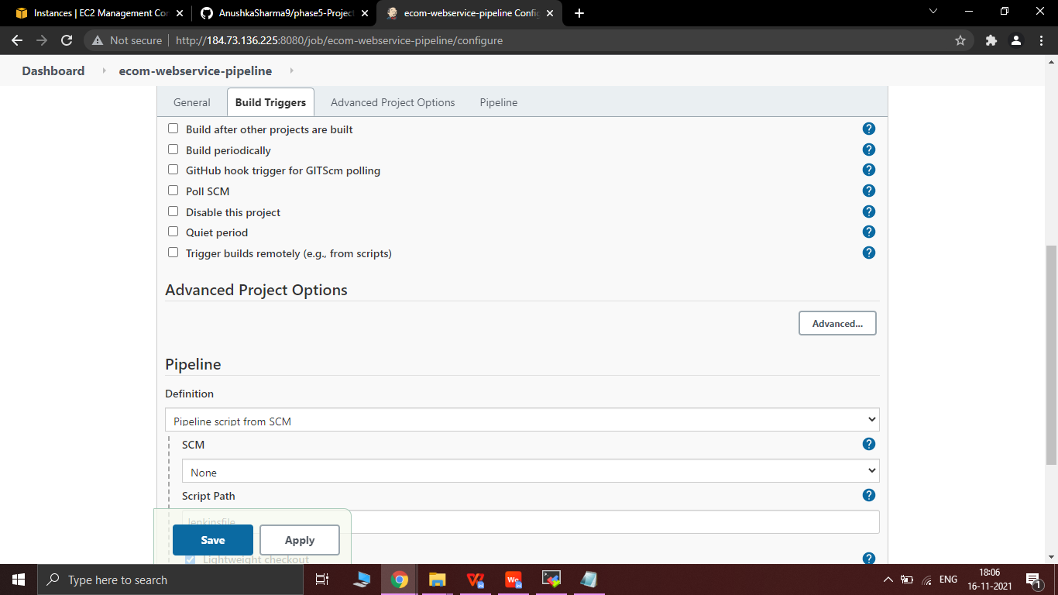

3.7 Put the git link in Repository URL : <https://github.com/AnushkaSharma9/phase5-Project-CI-CD-Deployment-for-Springboot-Application.git>

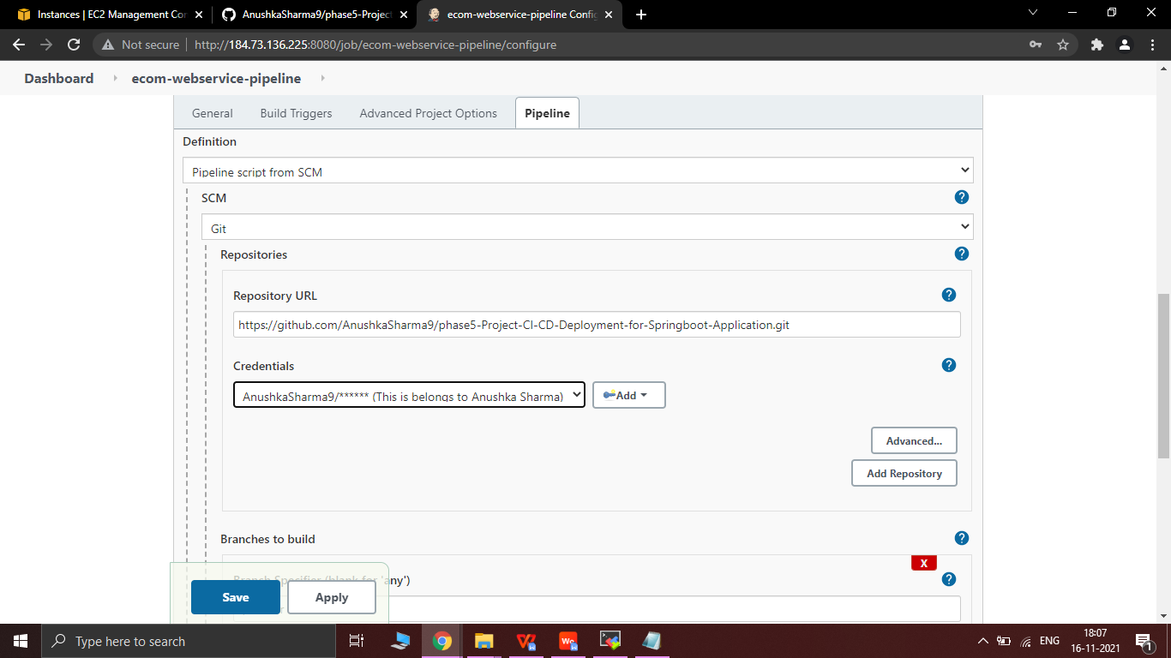

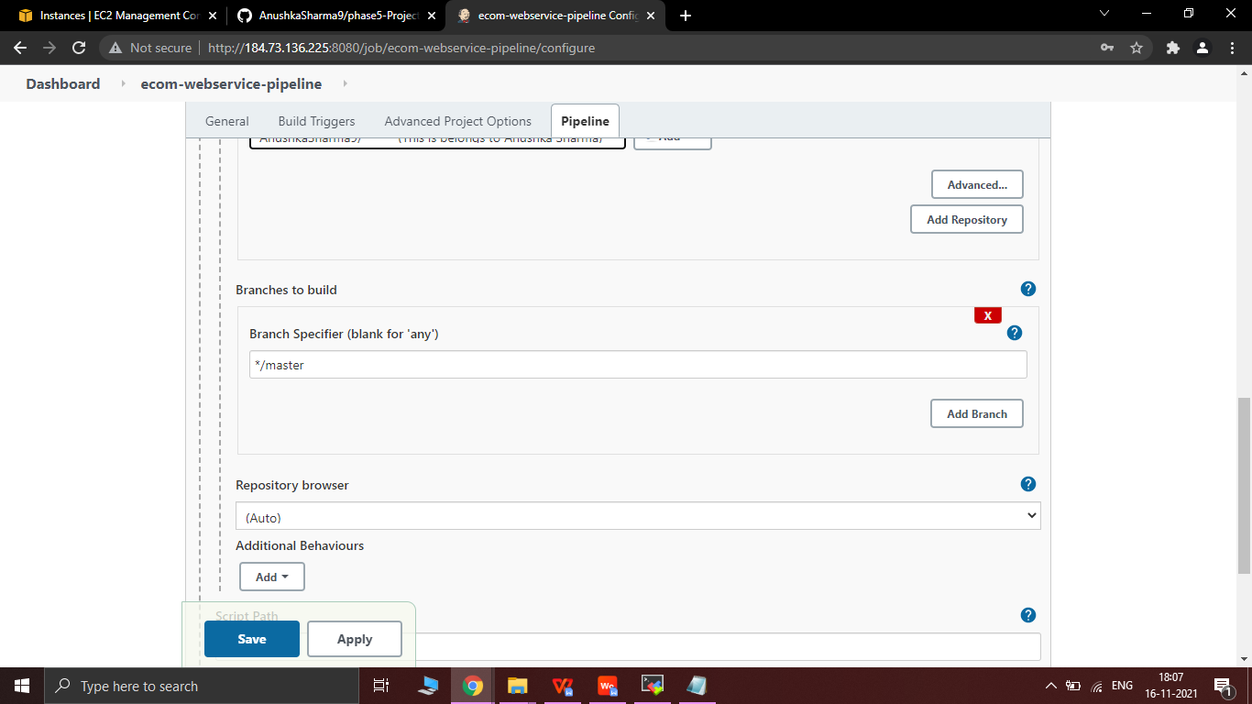

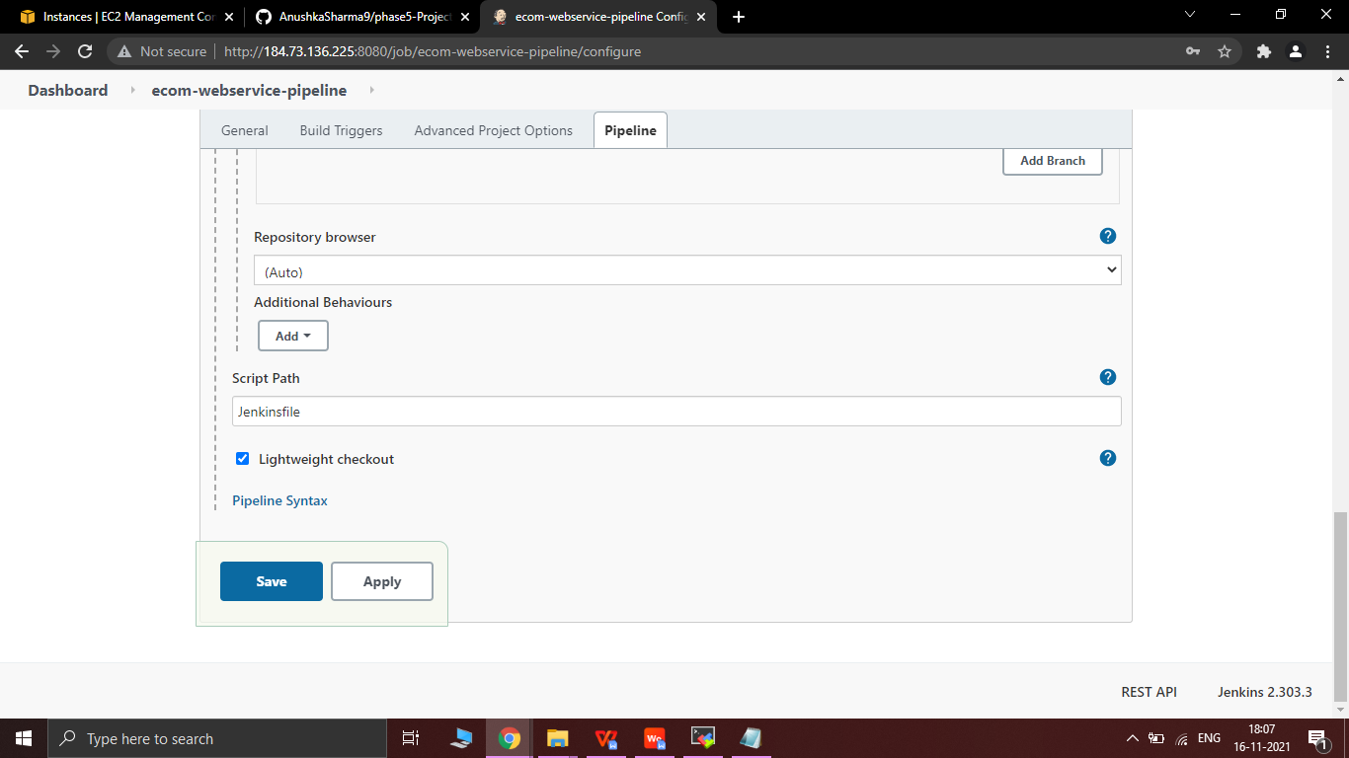

3.8 Click on Build Now to start a build

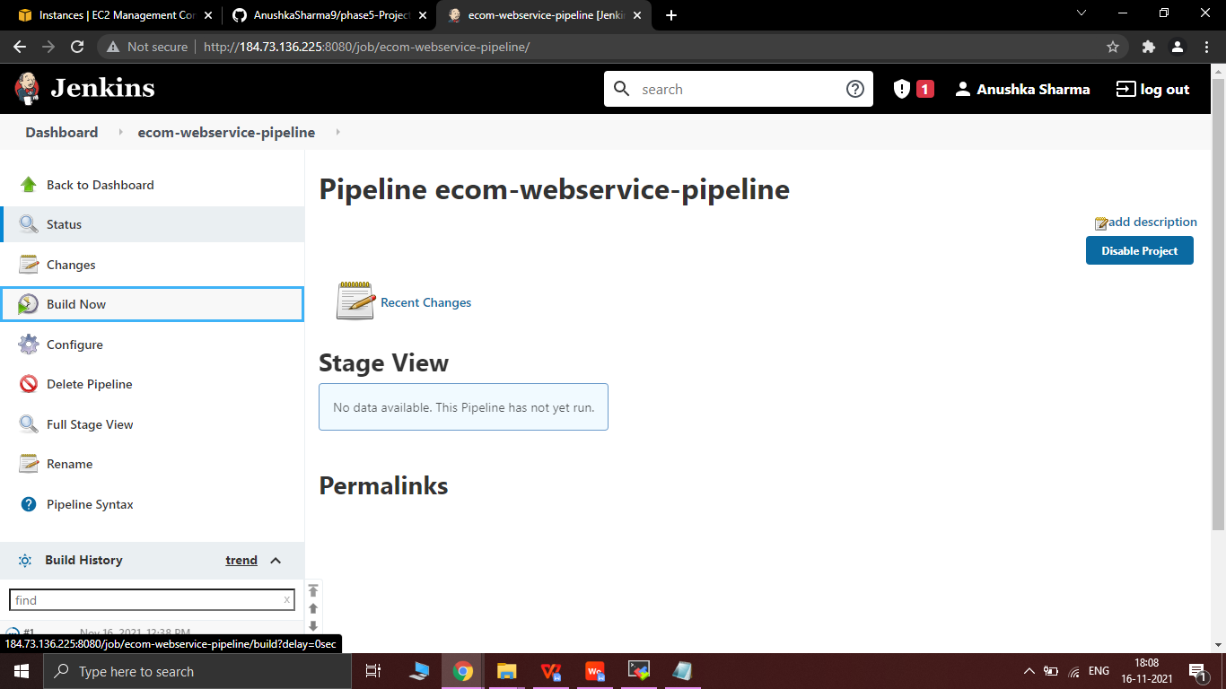

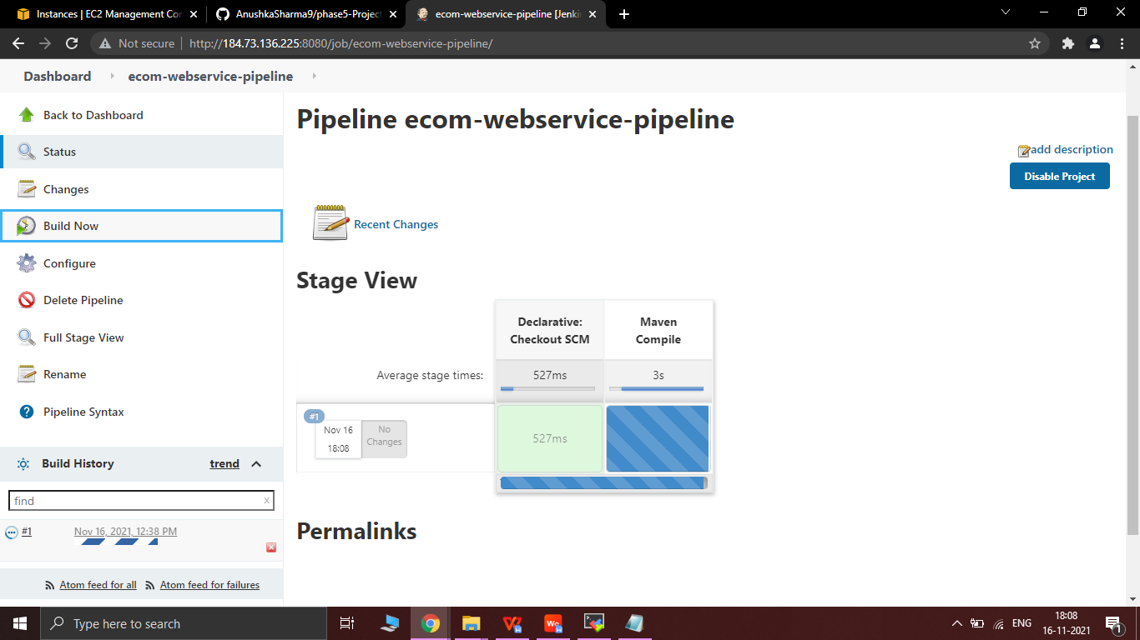

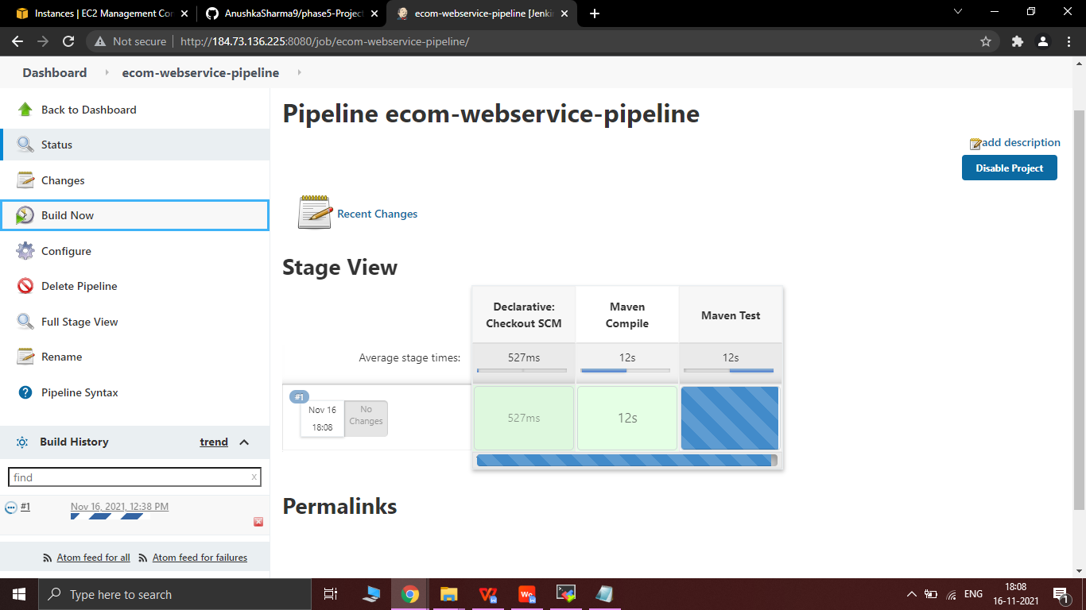

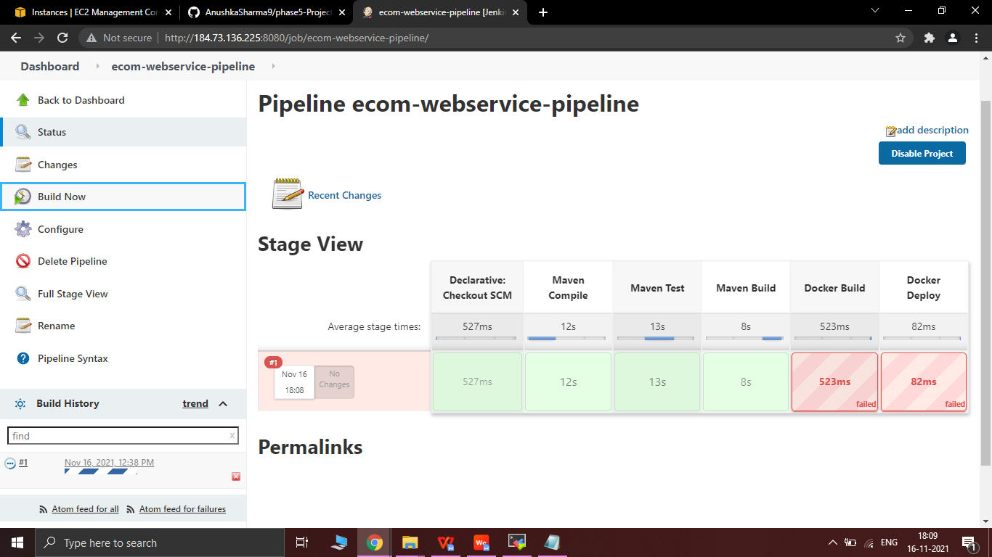

3.9 Console Output , Build 1 failed due permission denied -

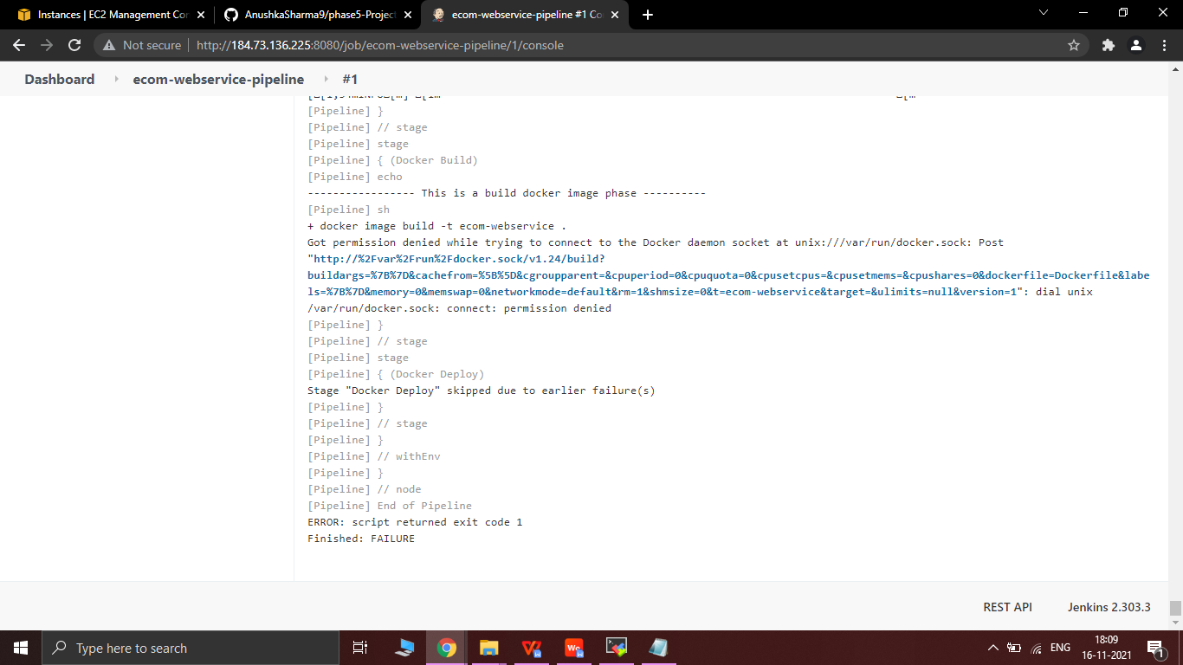

3.10 Running the following commands for permission denied -

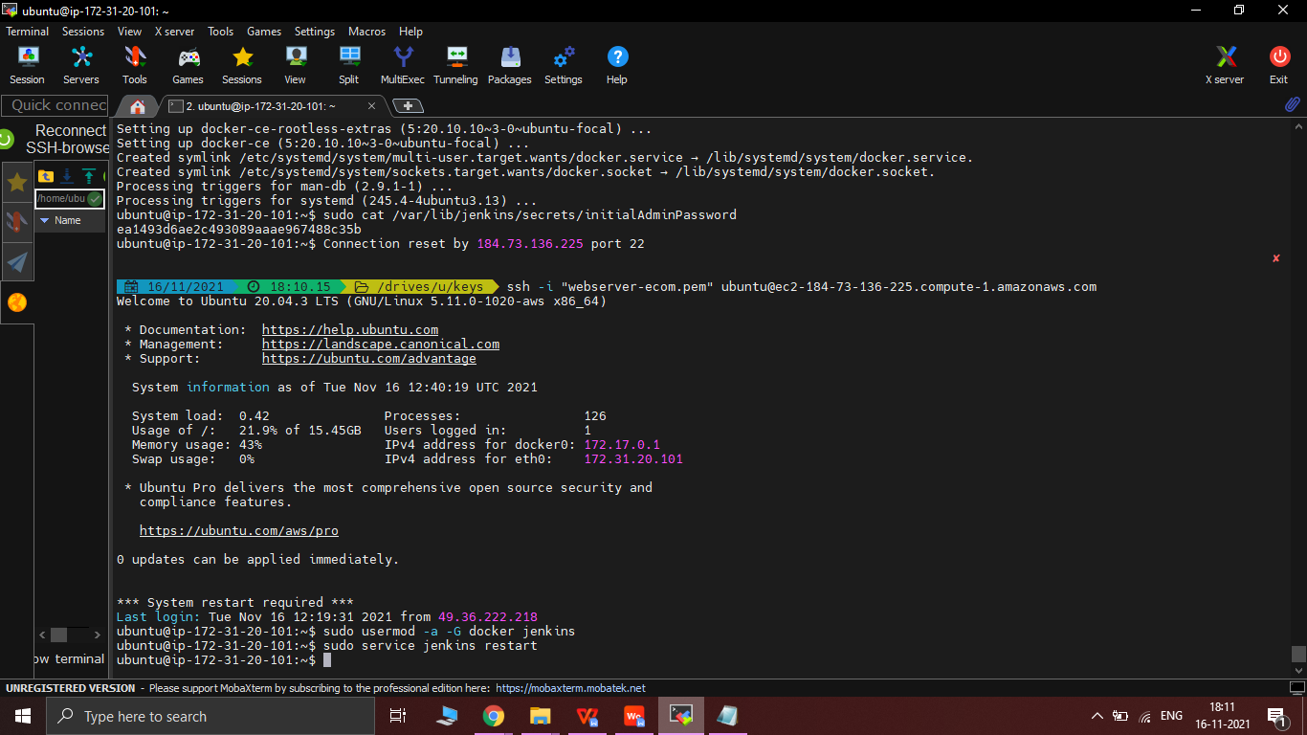

3.11 Restarting the Jenkins server again by refreshing the webpage -

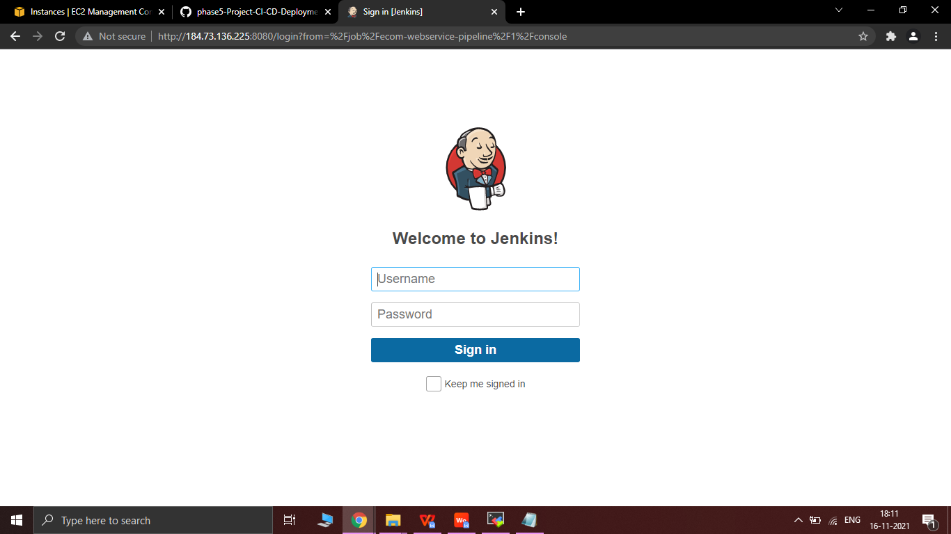

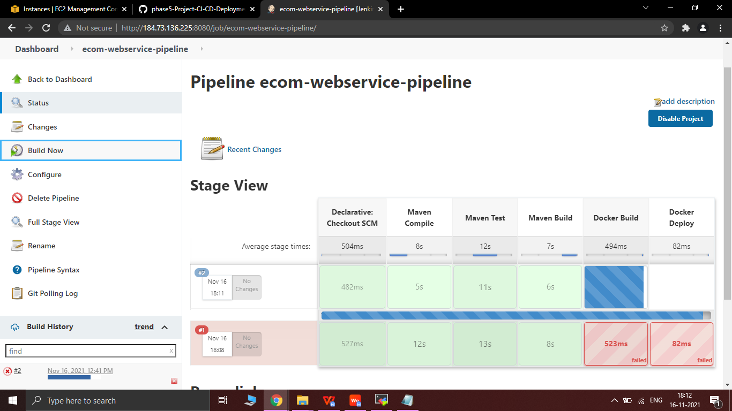

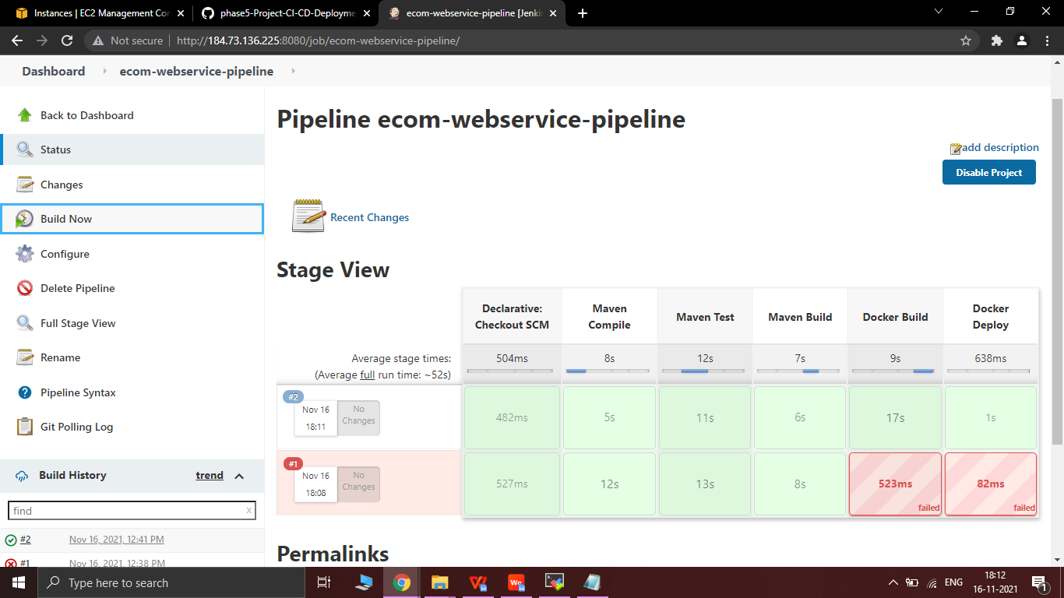

3.12 2nd Build Deployed Successfully

* Name of Project ->>**phase5-Project CI-CD Deployment for Springboot Application**
* Name of Package ->> **com.ecomerce.webapp**
* **DIRECTORY STRUCTURE / PACKAGE**

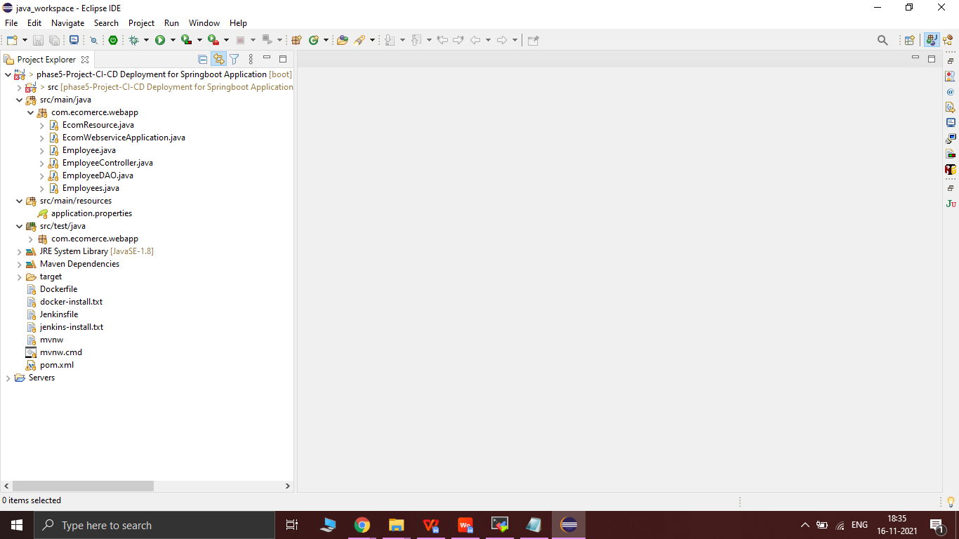

* **SCREENSHOTS OF OUTPUT**

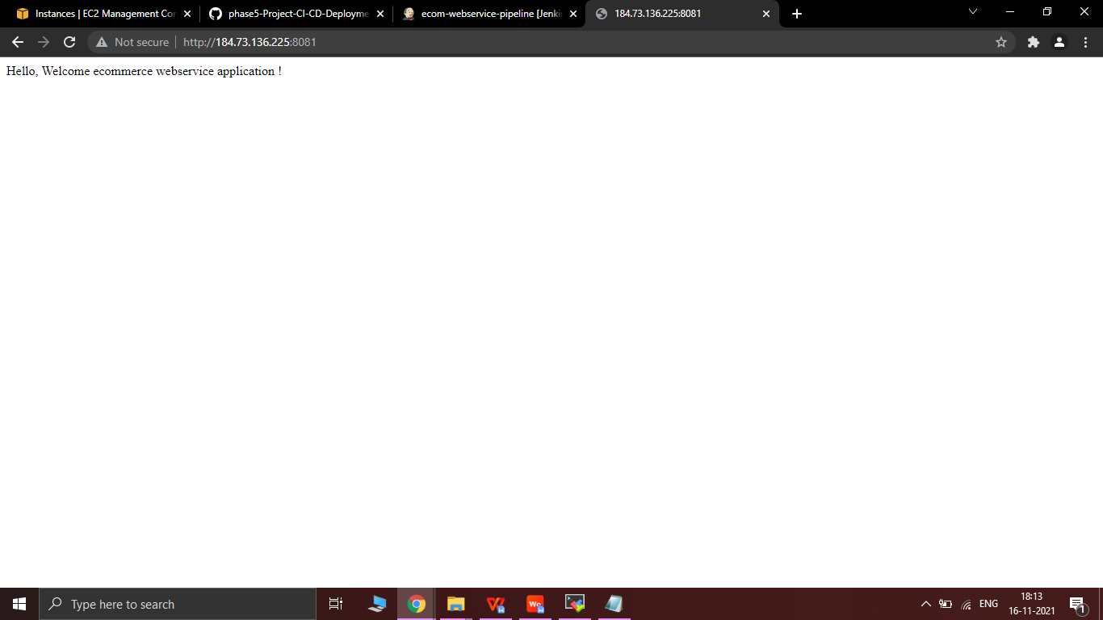

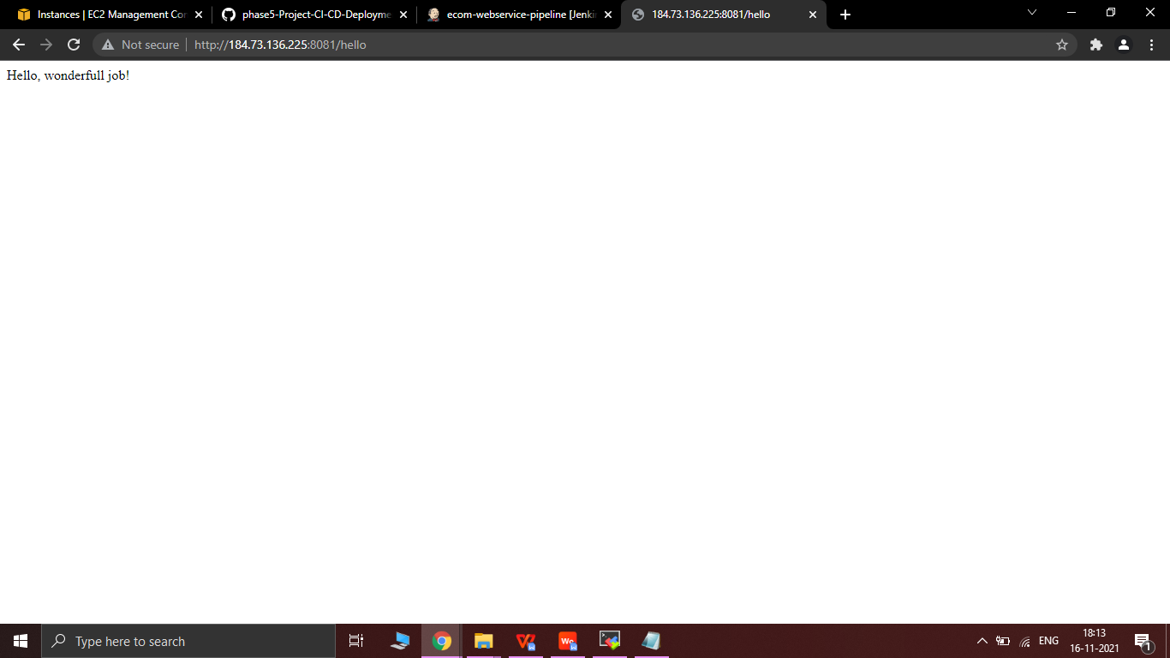

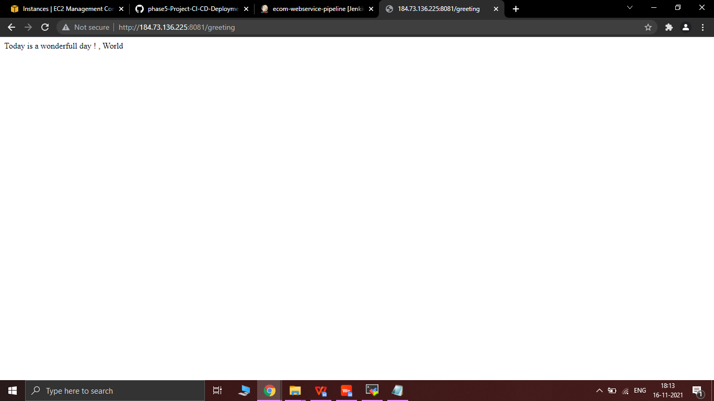

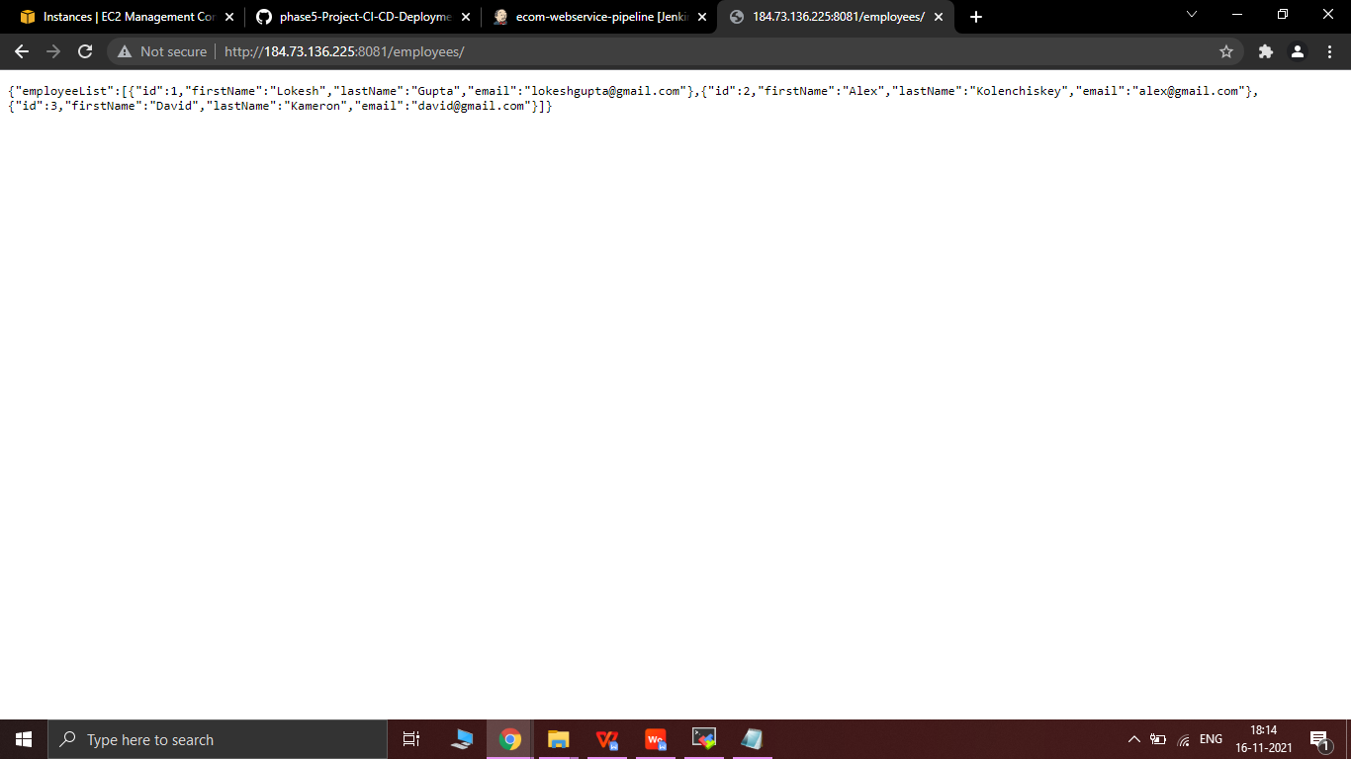

* Changes committed in Git are reflected in the Jenkins server as Build 3rd and Build 4th  automatically started the integration as well as deployment of the webapplication.
* Build 3rd done successfully after the commit.

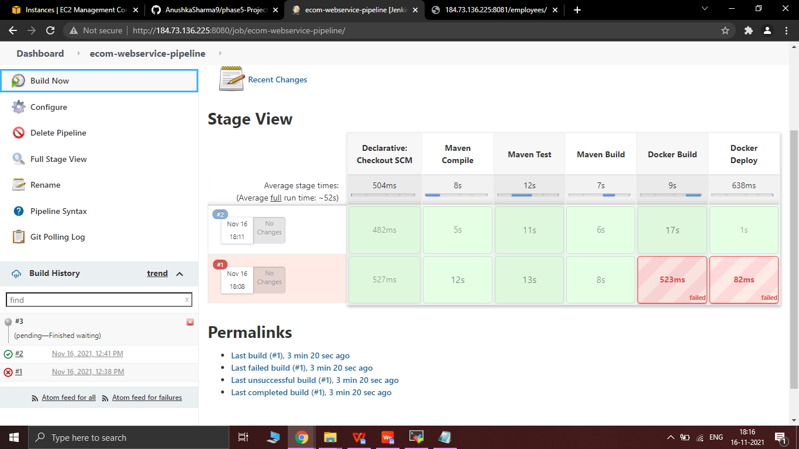

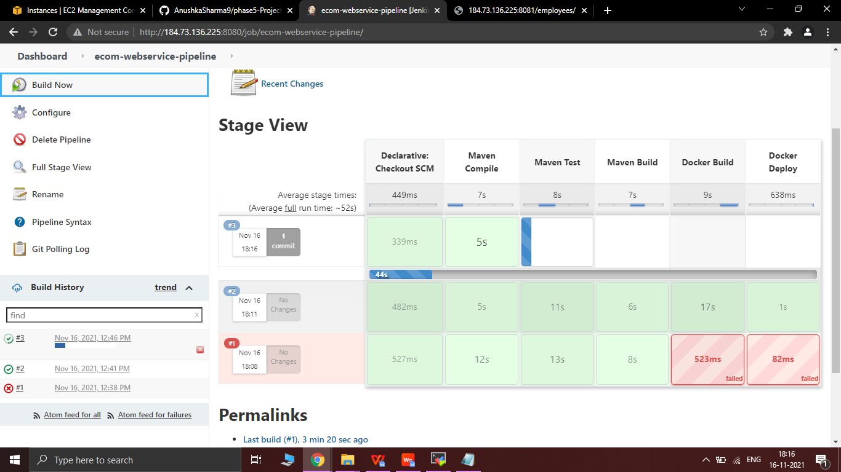

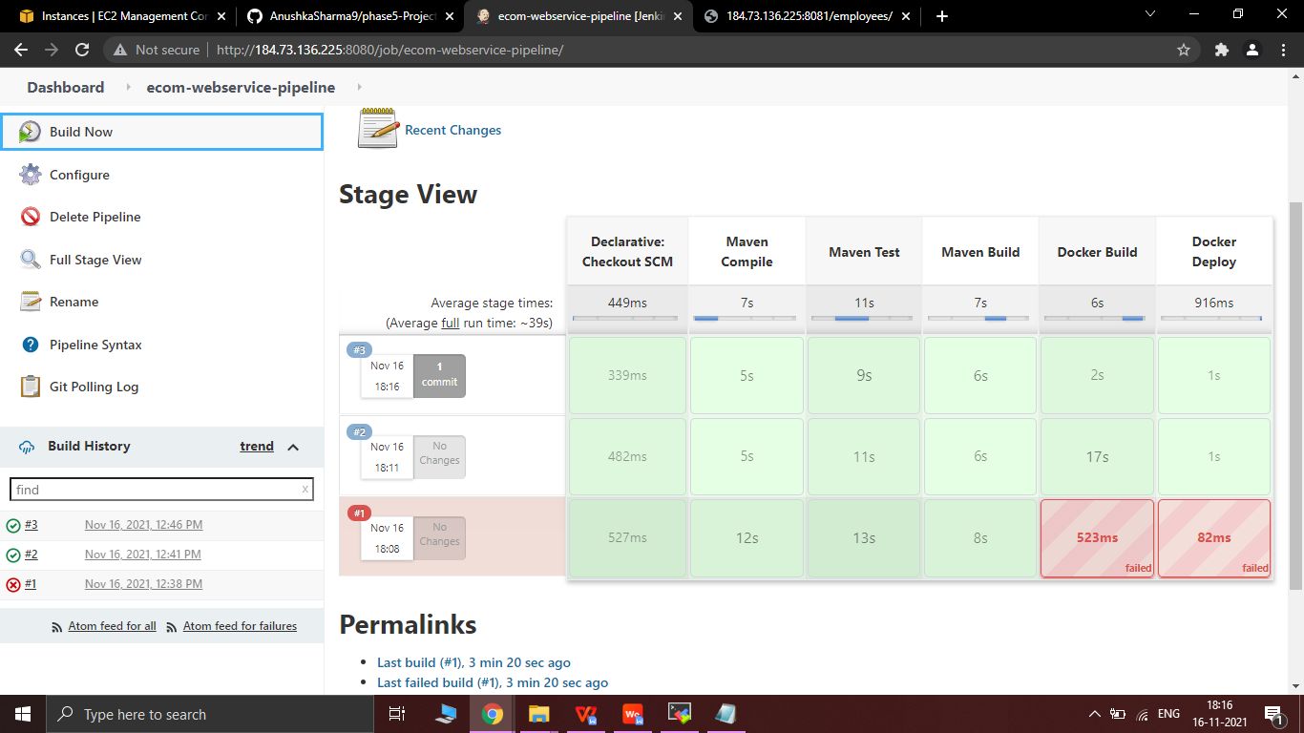

* Build 4th Done Successfully after the commit

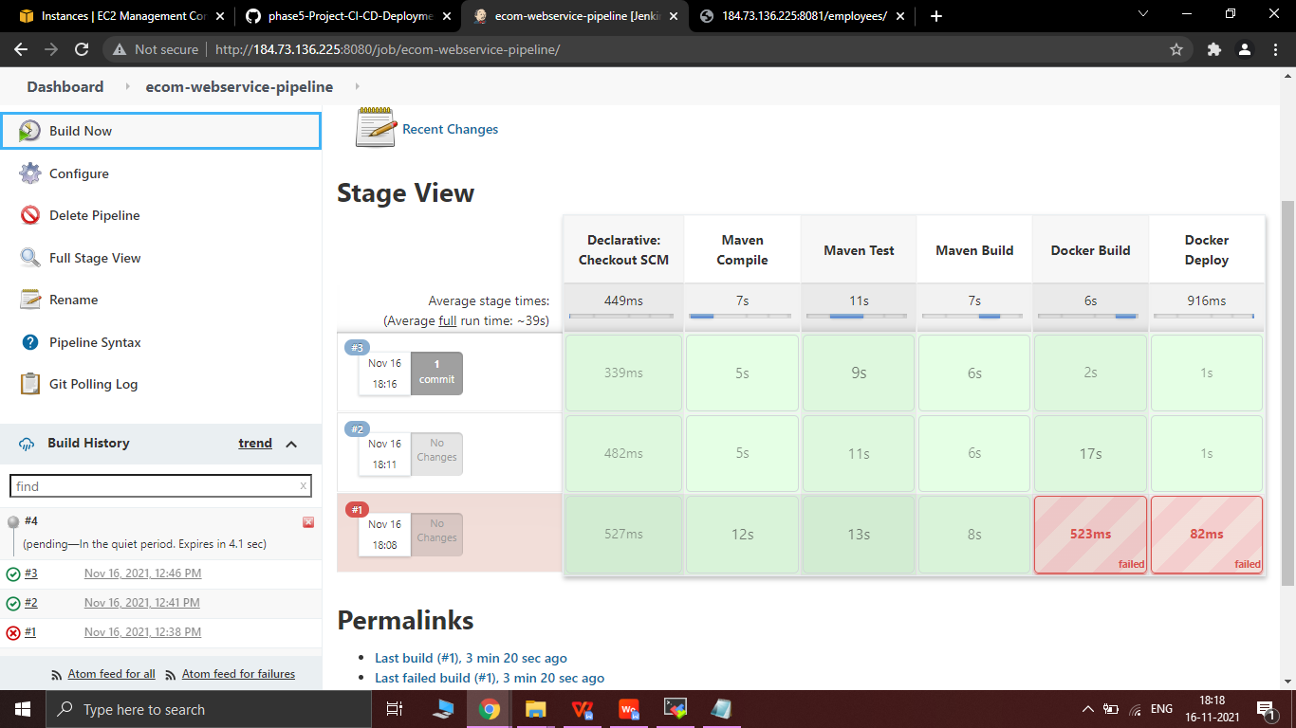

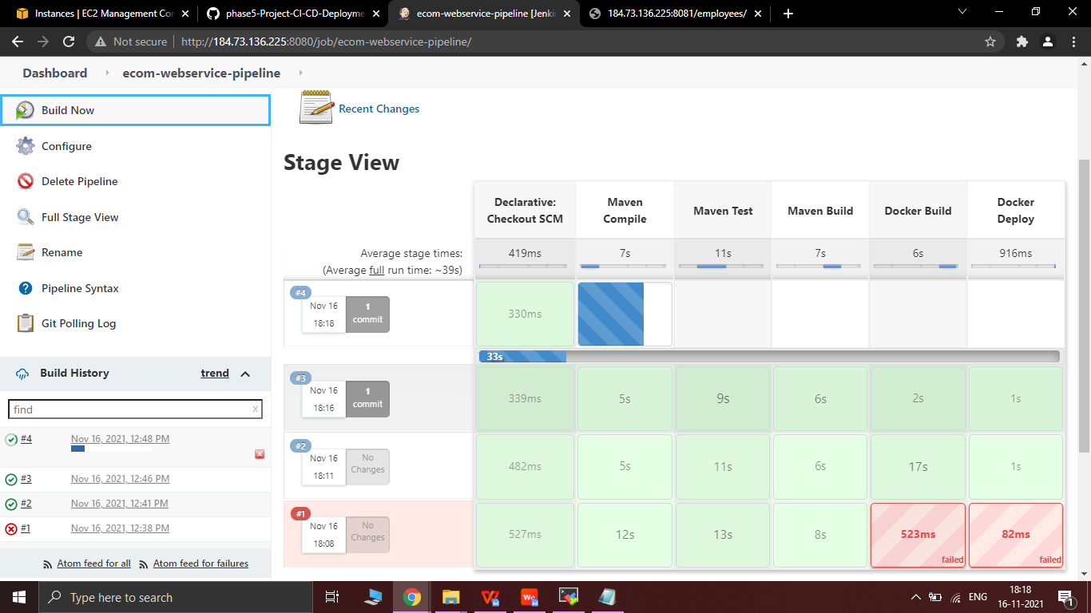

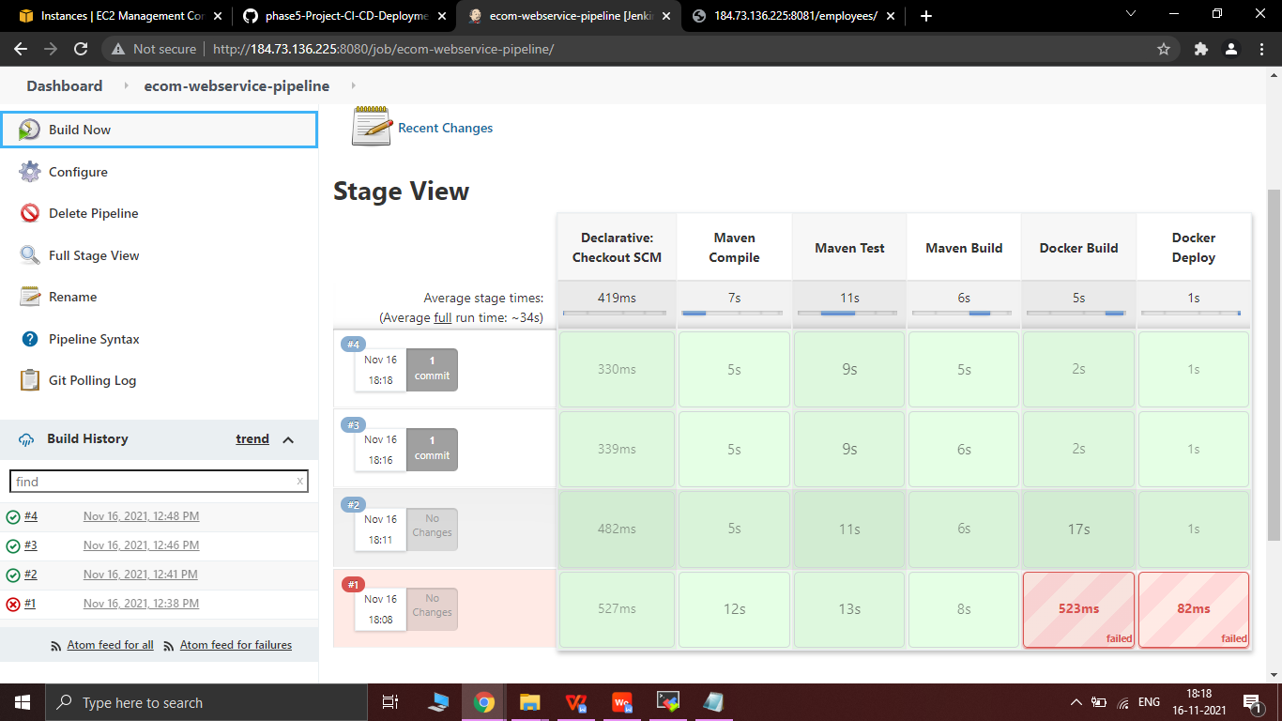

* Added employee name as Nisha Singh and email id - nisha@gmail.com in git and committed the changes .

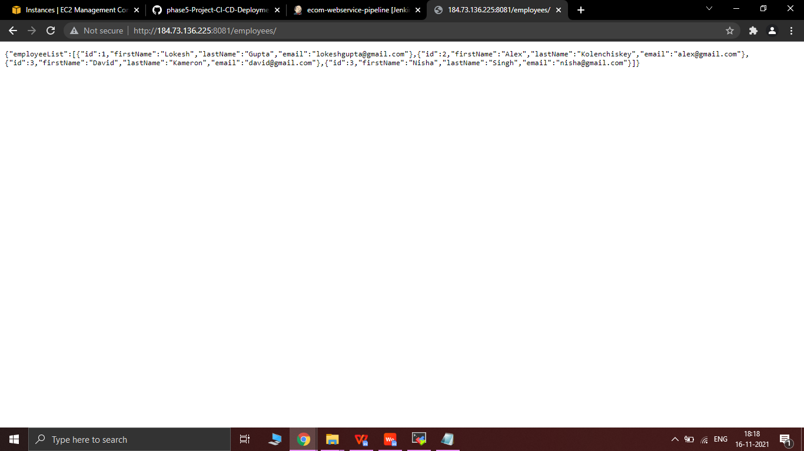

* Container and images running in Jenkins and docker server can be seen by using the commands below as shown in the picture.

